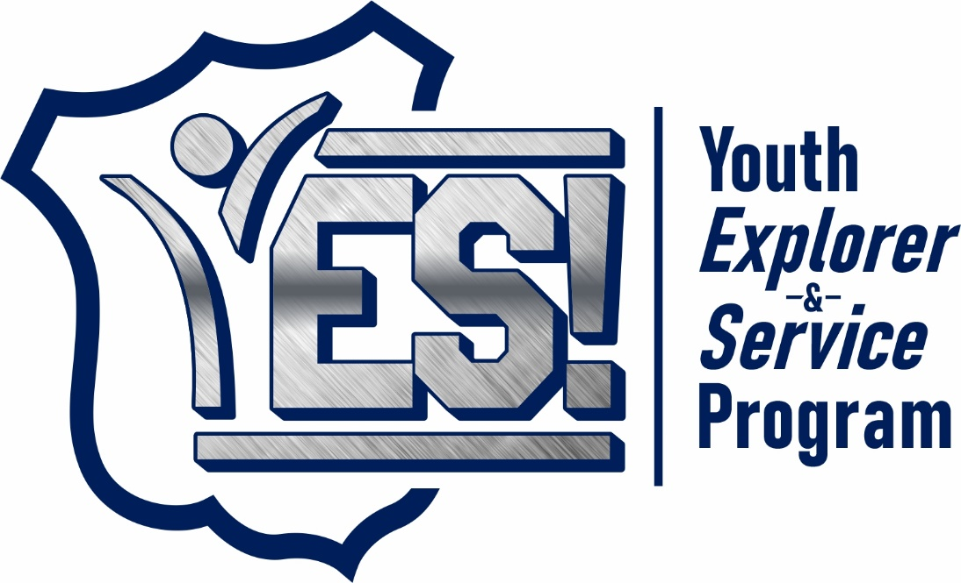
YES Structure
YES is a mentoring and professional development program for teens and young adults who have a desire to have a career in law enforcement. Each cadet will be assigned a mentor from the YES staff of volunteers chosen from the ranks of the Anniston Police Department. Cadets will gain working knowledge and experience through classroom activities and learning blocks, ride alongs with different APD divisions and shifts, physical fitness sessions, firearms safety and proficiency, interactive field trips, and more.
YES Acceptance Process
Applications for the program will be accepted by the Training and Inspections Unit of the Anniston Police Department and vetted through a selection process that includes, but is not limited to: interest in a law enforcement career, availability of mentors, cooperation from parents/guardians, application essay from the prospective cadet, etc.
YES Mission Statement
Our mission is to build meaningful relationships with the youth of our communities that will inspire and enable their passion to make a positive impact through a career of service in law enforcement.
YES Vision Statement
Working with our community partners, YES will provide mentorship, training, and resources to our cadets that will better prepare them to be successful public servants.
YES Core Values (CHIP)
Community- Excellent community service builds community trust and fosters meaningful relationships
Honor- We serve with honor in all we do. We honor the public trust we have been given, and we honor our fellow brothers and sisters who serve alongside us.
Integrity- We keep our professional and private lives above reproach.
Professionalism- Every interaction can either strengthen or degrade relationships with the communities we serve. Therefore, we are always professional and fair.

YES Contact Information
Lieutenant Brett Lloyd
256-240-4050
blloyd@annistonal.gov

Lieutenant Emily McCullars
256-240-4030
emccullars@annistonal.gov

