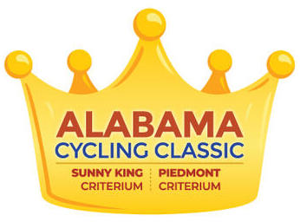

Alabama Cycling Classic to Reschedule
Criteriums in 2021
Event Sponsors Continue to Support Local Charities

Anniston, Ala. (June 2, 2020) - - Event organizers and City of Anniston officials have confirmed that this year’s Alabama Cycling Classic, and Noble Street Festival, have been cancelled due to continuing challenges related to the COVID-19 pandemic. Originally set for April 18-19, the Alabama Cycling Classic had been postponed while efforts were made to reschedule for a late summer date.

This year would have been the 18th consecutive Sunny King Criterium, part of the Noble Street Festival in downtown Anniston and a USA Cycling Pro Road Tour event. A second day of criterium racing was planned for Piedmont, Ala.

“It is very unfortunate to announce cancellation for this year. The COVID-19 pandemic has created numerous obstacles in all areas of operations. The decision to push out to 2021 was not easy, but all parties involved wanted to prioritize the safety and well-being of racers, residents, staff, and volunteers,” said Marilyn Hill, race director for the Alabama Cycling Classic. “In addition to safety, event leadership considered how to proceed with a quality experience for races and the festival. We deemed it safest to pursue cancellation over postponement for 2020.”

Hill has submitted a rescheduling request to USA Cycling for holding the Alabama Cycling Classic in a similar time slot for April 2021. The City of Anniston would reschedule the Noble Street Festival for the same Saturday as the Sunny King Criterium, which is the first day of racing for the Classic.

This year’s refund policy provides three options for athletes who were registered for the Alabama Cycling Classic. Individuals should use email (link in resources below) to request his or her refund option:
- Donate registration fees to Meals On Wheels, local beneficiary
- Roll registration fees to 2021
- Issue a full refund

Event staff and City of Anniston leadership would like to thank event sponsors for their patience and understanding. It is through the support of these sponsors that both the Noble Street Festival and Alabama Cycling Classic have been able to raise thousands of dollars each year for local organizations such as Meals on Wheels of Interfaith Ministries and Relay for Life of Calhoun County. More than $200,000 has been raised for both groups since 2002. The annual economic impact of event weekend is estimated to be more than $1.5 million each year.

Event sponsors Sunny King Automotive, Calhoun County Chamber of Commerce and Eastman Chemical have each committed to donate a portion of this year’s sponsorship fees to these charities to ease the challenges related to cancellation.

Hit hardest was Meals On Wheels, which delivers 18,500 meals to area seniors. It is having to source new funding this year. Previously, its main source of funding came from advertising dollars generated by a popular Festival Guide, produced by The Anniston Star.

The Sunny King Criterium attracts top talent from across the country as part of the PRT racing calendar. It has a strong reputation for southern hospitality, diversity of categorized events (women and men, juniors to elites), a hefty prize purse ($29,000 for weekend) and full day of free, live streaming for the Sunny King Criterium. The Noble Street Festival features the Sunny King Kids Zone, YMCA Kids Bicycle Races and Mad Dash 1K, and the Northeast Alabama Bicycle Association (NEABA) Fat Tire Crit.

In addition to Sunny King Automotive, sponsors for the Alabama Cycling Classic include, Alabama Power, Calhoun County Chamber of Commerce, Webb Concrete & Building Materials, B.R. Williams Trucking, Regions Bank, Regional Medical Center, Consolidated Publishing Company, Eastman Chemical Company, Multimetco, Wakefield’s/Martin’s Family Clothing Co., Merrill Lynch Wealth Management, State of Alabama Tourism Department – Sweet Home Alabama, Calhoun County Commission.

Resources:
Donate to Interfaith Ministries for Meals on Wheels - click here
Interfaith Ministries of Calhoun Co. - https://interfaithcalhoun.org
Relay for Life - Calhoun Co. - click here
Information on Noble Street Festival - email Sherrie
Alabama Cycling Classic refund information - email Marilyn

About Alabama Cycling Classic
The Sunny King Criterium began in 2002 as Anniston’s signature cycling event for professional and amateur male and female cyclists from around the globe. The title sponsor continues as Sunny King Automotive. A second day of racing was added in 2014 for amateur and elite athletes to create the ACC weekend. The start/finish line for the Sunny King Criterium is located at 11th and Noble streets in downtown Anniston, with 20 categorized races for adults and juniors. This is one of 17 national cycling events on USA Cycling’s Pro Road Tour. In 2020 the Piedmont Criterium was added to the weekend of bicycle races, sanctioned by USA Cycling. All races are managed by Start Smart Events.

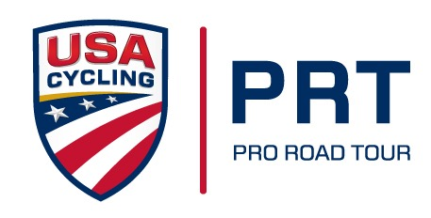
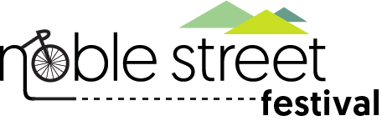
###

Web - annistoncycling.com Facebook - AlabamaCyclingClassic
Instagram - @AlabamaCyclingClassic Twitter - @AlabamaCycling #AnnistonCycling

