Executive Summary

ES-05 Executive Summary
- Introduction
The City of Anniston is an entitlement community and grantee of the U.S. Department of Housing and Urban Development’s (HUD) Community Development Block Grant (CDBG) Program. Funding available under this program is targeted within city limits to address community development needs with regard to affordable housing and supportive services for low to moderate income (LMI) families and communities. The City of Anniston also serves as the grantee for the Anniston HOME Consortium, which is a participating jurisdiction under HUD’s Home Investment Partnership Program (HOME). Funding under HOME is targeted to six jurisdictions – Anniston, Calhoun County (excluding Ohatchee and Oxford), Hobson City, Jacksonville, Piedmont and Weaver – to address affordable housing needs among low-to-moderate income (LMI) families.

The Consolidated Plan is a comprehensive document that describes the housing market conditions, identifies needs for affordable housing and community development and provides strategies to address the needs over the next five years. The plan coordinates the City’s housing and community development efforts with those of other public, private and nonprofit housing providers and non-housing service agencies. The resulting plan provides a unified vision for community development and housing actions with the primary goals of providing affordable housing and supportive services to LMI families, homeless persons, and populations with special needs (.e.g., elderly, disabled, etc.), improving public facilities and/or infrastructure, and eliminating slums and blight. The Year 1 Action Plan of the five-year planning period is also incorporated within this document and lays out the proposed use of funds for the first program year (October 1, 2013 – September 30, 2014).

- Summary of the objectives and outcomes identified in the Plan Needs Assessment Overview
Five goals have been established for the five-year consolidated planning period. They are:

Goal 1: Provide decent and affordable housing and supportive services for LMI families
Goal 2: Provide decent and affordable housing and supportive services for populations with special needs
Goal 3: Provide decent and affordable housing and supportive services for homeless populations
Goal 4: Improve public facilities and/or infrastructure
Goal 5: Eliminate slums and blight

- Evaluation of past performance
The City’s annual performance under the CDBG and HOME programs is documented in its Consolidated Annual Performance and Evaluation Report (CAPER), which is filed within 90 days of the end of each program year. Performance outcomes for the most recently completed program year (2011) are summarized below:

Funds Expended
CDBG Funds Spent - $845,113.38
HOME Funds Spent - $395,584.92
Total Expenditures - $1,240,698.30

13.99% of CDBG funds were expended for public services
79.93% of CDBG funds benefitted very low to moderate income persons

Units Assisted
CDBG Owner Occupied Rehab – 10 Units
CDBG Deferred Loan Rehab – 11 Units
CDBG – Minor Repairs World Changers – 9 Units
HOME – Owner Occupied rehab – 2 Units
HOME – CHDO Acquisition & Rehab – 2 Units
Total Units - 34 units

Persons Assisted
HOME 7
CDBG:
Public Service Agencies (8) 15,535
Housing Rehab 33
Total Persons 15,575

4. Summary of citizen participation process and consultation process
As the grantee for both CDBG and HOME, the City conducted a consolidated citizen participation process, which combined public hearings and agency consultation meetings, yet acknowledged the programs as two separate and distinct programs. All required citizen participation activities were carried out in compliance with its approved Citizen Participation (CP) Plan, and all activities were conducted in compliance with timeframes set under federal program regulations.

5. Summary of public comments
Three public hearings (May 16th, July 24th and August 13th) were convened during the development of the Five-Year Consolidated Plan to solicit public input and feedback from residents of the communities covered under HOME and CDBG. An Agency Consulting Meeting was also convened (June 11th) to obtain input from housing-related and non-housing-related service providers operating within the covered jurisdictions to meet the needs of residents. In summary, the following comments were offered by the public with regard to community needs:

- Strategic use of federal funds for greater impact
- Affordable housing including group homes
- Fair housing education and outreach
- Transitional and permanent housing for the homeless
- Supportive services to meet the needs of LMI families
6. Summary of comments or views not accepted and the reasons for not accepting them
All comments received were given appropriate consideration and were weighed in conjunction with housing and community data, needs assessment data, input and feedback from service providers, and specific funding requests. No comments were rejected.

7. Summary
For Program Year 2013 (October 1, 2013 – September 30, 2014), the following amounts have been awarded by the U.S. Department of Housing and Urban Development (HUD). A summary of proposed activities to be carried out is shown below. A detailed summary of specific projects and allocations is included in the Strategic Plan section of this document.

CDBG $538,763 62.4%
CDBG Program Income $3,900 .5%
HOME Program $317,734 36.8%
HOME Program Income $3,000 0.3%
Total Funding $863,397 100%

CDBG

Administration $94,966 17.5%
Planning and Management $13,602 2.5%
Public Services $81,399 15.0%
Slum/Blight Removal $62,696 11.6%
Public Facilities Improvement $210,000 38.7%
Housing Rehabilitation (Single and Multi-Family) $80,000 14.7%
$542,663 100%

HOME

Administration $32,073 10%
Community Housing Development Organization (CHDO) $48,110 15%
Affordable Housing Construction & Rehabilitation $220,551 68.8%
Acquisition $20,000 6.2%
$320,734 $100%
The Process

PR-05 Lead & Responsible Agencies
1. Agency/entity responsible for preparing/administering the Consolidated Plan
The following are the agencies/entities responsible for preparing the Consolidated Plan and those responsible for administration of each grant program and funding source.
Agency Role | Name | Department/Agency
Lead Agency | City of Anniston | Community Development

Table 1 – Responsible Agencies

Narrative
Consolidated Plan Public Contact Information
Don Hoyt
City Manager
City of Anniston
1128 Gurnee Ave
Anniston, AL 36201
256-236-3422
dhoyt@annistonal.gov

PR-10 Consultation
Summary of the jurisdiction’s activities to enhance coordination between public and assisted housing providers and private and governmental health, mental health and service agencies
The City has used multiple strategies to enhance coordination between agencies, including the allocation of General Fund dollars, Federal grant dollars (CDBG and HOME), and state awarded dollars (ESG) to support the provision of services within the covered jurisdictions, as well ongoing communication and consultation with housing and non-housing service providers, public housing authorities, other local jurisdictions, and public agencies. In the HOME program, the City has maintained a strong and productive relationship with Habitat for Humanity and with its CHDO, Northeast Alabama CDC, in producing affordable housing units. In CDBG (and possibly in HOME in the coming year), steps have been taken to improve the working relationship between the City and another non-profit—the Calhoun County CDC, with whom we expect to partner.

In the City’s upcoming fiscal year (starting October 1st), the allocation of General Fund dollars to public service agencies will be outsourced to and managed by the Community Foundation of East Alabama. It is anticipated that this will result in leveraging additional support for non-profits engaged in community work. Several service providers are currently funded under the City’s Operating Budget using General Funds, as well as the CDBG program using federal funds. The City intends to continue to fund agencies engaged in public services within program limits. In order to ensure transparency, increase efficiency, and avoid the possibility of allocating two different sources of funding for the same purpose or expenses, the City will provide the Community Foundation with award information, including a summary of expenses covered under CDBG.

Describe coordination with the Continuum of Care and efforts to address the needs of homeless persons (particularly chronically homeless individuals and families, families with children, veterans, and unaccompanied youth) and persons at risk of homelessness
The City actively participates in the Homeless Coalition of North East Alabama (HCNEA), the regional Homeless Continuum of Care (CoC) for Calhoun County and its surrounding areas. Efforts to address the needs of the homeless include participation in CoC meetings, the allocation of General Fund dollars for homeless provider assistance, and the allocation of CDBG funding under the 15% public services cap to organizations meeting the housing and supportive services needs of homeless persons.

Describe consultation with the Continuum(s) of Care that serves the jurisdiction's area in determining how to allocate ESG funds, develop performance standards and evaluate outcomes, and develop funding, policies and procedures for the administration of HMIS
The City does not receive a direct federal allocation, but was awarded an Emergency Solutions Grant (ESG) grant in the amount of $127,161 by the Alabama Department of Economic and Community Affairs (ADECA) for the period June 2012 through April of 2014. Services funded under the grant support CoC activities for the homeless including:

Family Services Center ($85,000) - Street outreach services, rapid re-housing services and assistance, and homeless prevention services and assistance

Health Services Center ($12,000) - Essential services (mental health & substance abuse) and shelter operations

Community Enabler Developer ($30,000) - Rent and utility assistance.

As in the past, the City will also allocate a portion of its administration/planning and management funds under CDBG to HCNEA for the administration of the Homeless Management Information System (HMIS). The City and CoC also work in cooperation with Jacksonville State University to develop performance standards, conduct point in time (PIT) homelessness counts and evaluate outcomes.

- Agencies, groups, organizations and others who participated in the process and consultations
Several methods were used to solicit input and feedback from agencies and groups for the development of the Five-Year Consolidated Plan. They included public hearings, an agency consultation meeting, and the opportunity to submit written comments. The following table summarizes those which participated.

Agency/Group/Organization | Agency/Group/Organization Type | What section of the Plan was addressed by Consultation? | How was the Agency/Group/Organization consulted and what are the anticipated outcomes of the consultation or areas for improved coordination?
HCNEA | CoC | Homeless Needs | Participation in CoC, PIT survey data use of published data
Anniston Housing Authority | Public Housing | Public Housing | Public Hearing, Agency Consultation meeting,
Boys and Girls Club | Nonprofit | Unmet needs | Public Hearing, Agency Consultation meeting
Pre School Friends | Nonprofit | Unmet needs | Agency Consultation meeting
Salvation Army | Nonprofit | Unmet needs | Agency Consultation meeting
Family Services Center | Nonprofit | Unmet needs | Agency Consultation meeting
2nd Chance | Nonprofit | Unmet needs | Agency Consultation meeting
The Right Place | Nonprofit | Unmet needs | Agency Consultation meeting
St. Michael’s | Nonprofit | Unmet needs | Agency Consultation meeting
Anniston Soup Bowl | Nonprofit | Unmet needs | Agency Consultation meeting
Community Foundation of East Alabama | Foundation | Unmet needs | Agency Consultation meeting
Interfaith | Nonprofit | Unmet needs | Agency Consultation meeting
United Way | Regional | Unmet needs | Agency Consultation meeting
Jacksonville State Univ | Higher Education/Univ. | Homeless Needs | Use of PIT and assessment of homelessness data
Habitat for Humanity | Nonprofit | Housing needs | Public Hearing, Agency Consultation meeting
Table 2 – Agencies, groups, organizations who participated
Identify any Agency Types not consulted and provide rationale for not consulting
Not Applicable
Other local/regional/state/federal planning efforts considered when preparing the Plan
Name of Plan | Lead Organization | How do the goals of your Strategic Plan overlap with the goals of each plan?
Analysis of Impediments to Fair Housing | East Alabama Regional Planning and Development Commission | Identification of fair housing education as an unmet need
Anniston Five-Year Consolidated Plan2008-2012 | Anniston | Identification of unmet needs and goals for target area
Clear Plan 2030 Existing Conditions Document – Summer 2012 | East Alabama Regional Planning and Development Commission | Summary of demographic data for the target area and identification of disproportionately impacted populations
Table 3 – Other local / regional / federal planning efforts
Describe cooperation and coordination with other public entities, including the State and any adjacent units of general local government, in the implementation of the Consolidated Plan (91.215(l))
In accordance with CFR 24 91.215(l), the City made every effort to cooperate and coordinate with other public entities, with a particular emphasis on the adjacent jurisdictions (Jacksonville, Piedmont, Hobson City, Weaver, and Calhoun County) which comprise the Anniston HOME Consortium served by the HOME program. The HOME Consortium Board meets at least quarterly.

PR-15 Citizen Participation
1. Summary of citizen participation process/Efforts made to broaden citizen participation

Citizen participation is a critical component of the CDBG and HOME programs with regard to determining community needs, goals, and priorities. All citizen participation activities were implemented in compliance with the City’s approved Citizen Participation (CP) Plan, including advanced notice of public hearings, three public hearings, and implementation of a community needs assessment survey. Efforts made to broaden citizen participation included setting public hearings at times and locations that were convenient to the public, posting all process information on the City of Anniston’s publicly accessible website, and sharing all information with local jurisdictions, service providers and the housing authority for public posting in their facilities or on their websites. Notices of the availability of all documents in hard copy form were also posted for residents who do not have internet access or preferred to view a hard copy.

Summarize citizen participation process and how it impacted goal-setting

Input and feedback obtained as a result of the CP activities listed above were heavily weighed in combination with community data, feedback from service providers, and other input to establish the goals and priorities listed within this plan.

Citizen Participation Outreach
The following information is applicable to both CDBG and HOME as a result of the consolidation of the two programs’ citizen participation processes.

Mode of  Outreach | Target of Outreach | Summary of response/ attendance | Summary of comments received | Summary of comments not accepted and reasons | URL (If applicable)
Public Hearings | Non-targeted/broad community | May 16th – 14 attendees  July 24th – TBD  August 9th – TBD | Identified Needs:  Strategic use of funds for greater impact; Affordable housing including group homes;  Fair Housing education; | N/A | N/A
Agency Consultation Meeting | Housing and Non-Housing Service Providers | 17 attendees | Identified Needs:  Downsize public housing; Barrier removal for affordable housing; Info re: available housing assistance; Transportation assistance; Emergency shelter & transitional/ permanent housing & services; Flexible models of service delivery; Assistance for elderly | N/A | N/A
Online Community Needs Assessment Survey | Non-targeted/broad community | 43 respondents | Highest Ranked Needs: Single-family home repair; Job creation; Job training; Housing for homeless; Educational services for youth | N/A | www.annistonal.gov
Table 4 – Citizen Participation Outreach

Needs Assessment

NA-05 Overview
Needs Assessment Overview
In accordance with the CP Plan, a Community Needs Assessment Survey was administered by the City’s Community Development Department as an additional means of obtaining citizen input regarding community needs and priorities. The 21 question survey was posted online, however residents were offered the opportunity to complete the survey in hard copy if requested (no such requests were made). An advertisement was placed in the Anniston Star notifying the public of the survey opportunity, and any resident of Calhoun County was encouraged to complete it to ensure participation from jurisdictions included under both the CDBG and HOME programs. Information concerning the survey was also shared with the representatives of each jurisdiction of the HOME Consortium who were encouraged to post the information on their public websites and share it with their residents. As a third means of outreach, the survey information was also shared with the attendees of the first public hearing and the agency consultation meeting.

The total number of survey respondents was 43. Unfortunately, this number does not provide a representative sampling of the population as a whole, but it does provide insight regarding the areas and needs that residents rank highest. Overall, 95% of respondents live in Calhoun County (2 respondents did not), with 60.5% (26) living in Anniston, and over half living in two zip codes - 36207 (35%) and 35901 (21%). Homeowners represented 72% of respondents, while renters made up 26% and one person indicated they lived with someone else.

Analysis of Needs Assessment Respondents by Zip code
Zip code | Total | % | Zip code | Total | %
36207 | 15 | 34.8% | 36202 | 1 | 2.3%
35901 | 9 | 20.9% | 36277 | 1 | 2.3%
36265 | 5 | 11.7% | 35901 | 1 | 2.3%
36203 | 5 | 11.7% | 36205 | 1 | 2.3%
36206 | 4 | 9.4% | 36260 | 1 | 2.3%
Total Respondents = 43 (100%)

Respondents were asked to rank eligible areas of need using a scale of high, medium, low, none or no opinion. The table below summarizes the top five needs which garnered the highest percentage of residents ranking it as high need, followed by a summary of all queried needs and graphic representations of the survey results. All five needs are reflected in the goals established within the Strategic Plan.
Top Five Needs by Response
Area of Need | % Ranking as High Need
Repair Existing Homes Owned by LMI Families | 76.32%
Financing for Projects to Create Jobs | 76.32%
Financing Programs for Job Training | 76.32%
Providing Housing for Homeless Persons | 75.68%
Educational Services for Youth | 75%

Summary of Survey Responses by Question
Area of Need | High | Med | Low | No | No Response
Low interest loans to 1st time LMI buyers | 65.79% | 18.42% | 10.53% | 0% | 5.26%
Building new single-family homes for LMI buyers | 62.16% | 21.62% | 13.51% | 0% | 2.7%
Repair existing single-family homes of LMI owners | 76.32% | 21.05% | 0% | 0% | 2.63%
Building new multi-family housing for LMI renters | 55.26% | 26.32% | 13.16% | 2.63% | 2.63%
Repairing existing multi-family housing for LMI renters | 63.16% | 23.68% | 10.53% | 0% | 2.63%
Providing services for the homeless | 65.79% | 18.42% | 10.53% | 0% | 5.26%
Providing housing for the homeless | 75.68% | 10.81% | 10.81% | 0% | 2.7%
Providing services for special needs | 67.57% | 29.73% | 2.7% | 0% | 0%
Providing housing for special needs | 63.16% | 21.05% | 13.16% | 0% | 2.63%
Providing water/sewer in LMI areas | 52.63% | 23.68% | 15.79% | 2.63% | 5.26%
Improving public infrastructure or community facilities | 47.37% | 34.21% | 15.79% | 2.63% | 0%
Fair Housing awareness | 55.26% | 26.32% | 15.79% | 0% | 2.63%
Educational services for youth | 75% | 16.67% | 5.56% | 2.78% | 0%
Low interest loans for businesses | 65.79% | 26.32% | 5.26% | 0% | 2.63%
Projects to create jobs | 76.32% | 18.42% | 2.63% | 0% | 2.63%
Programs for job training | 76.32% | 18.42% | 2.63% | 0% | 2.63%

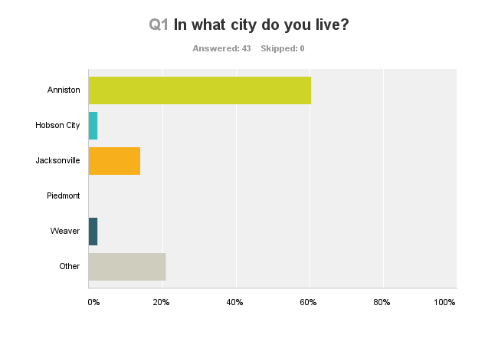
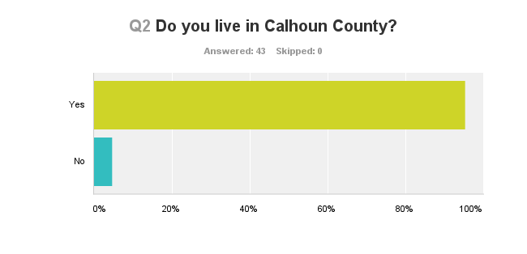
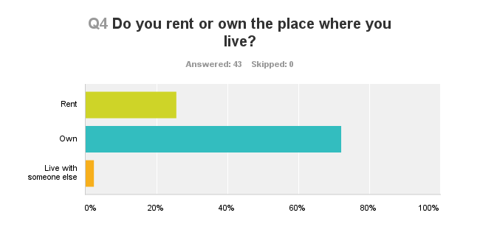
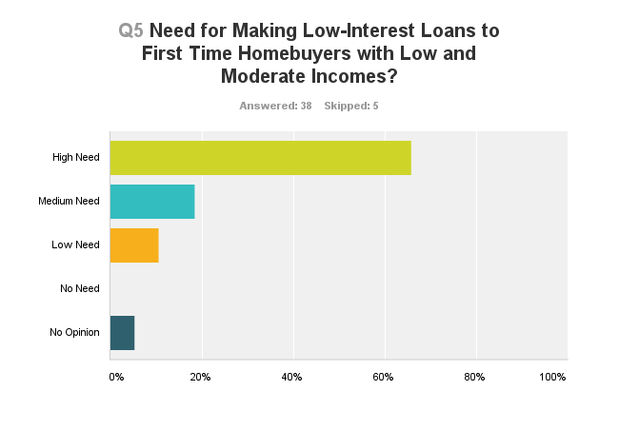
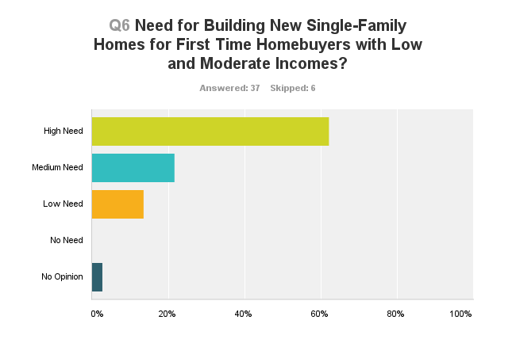
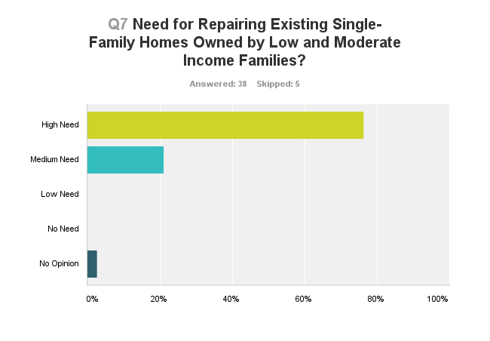
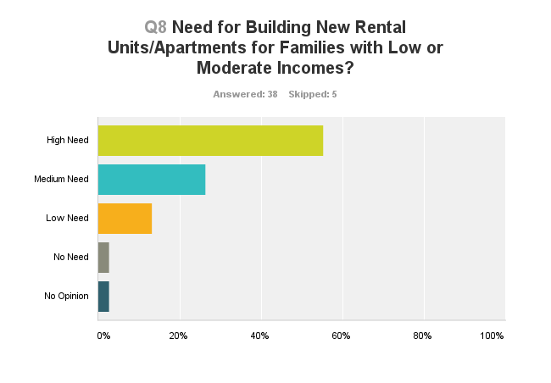
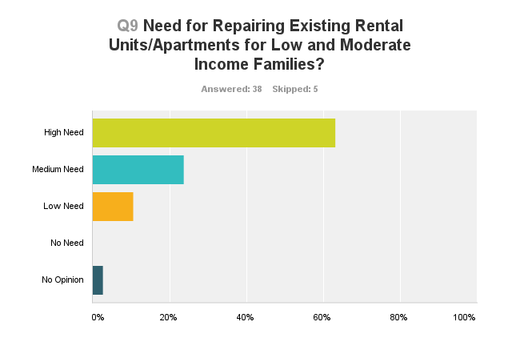
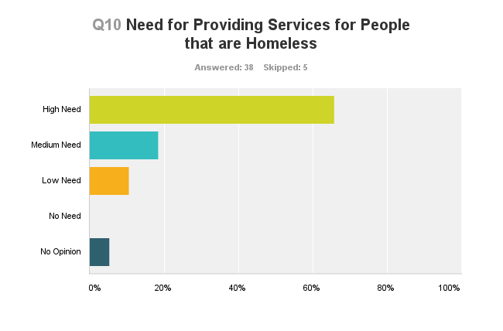
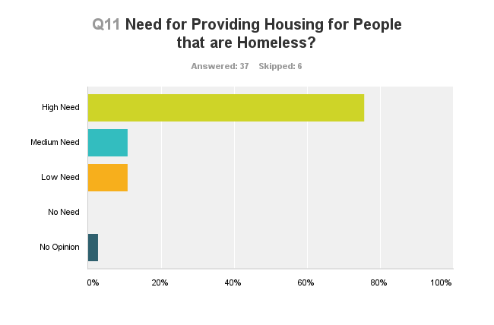
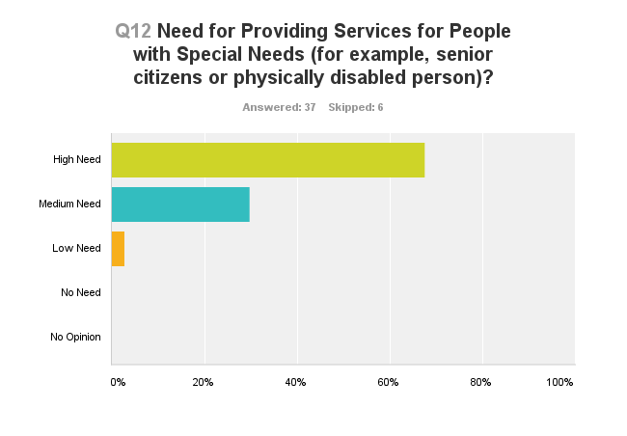
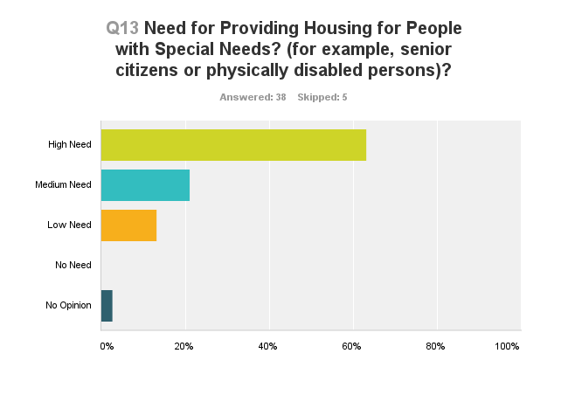
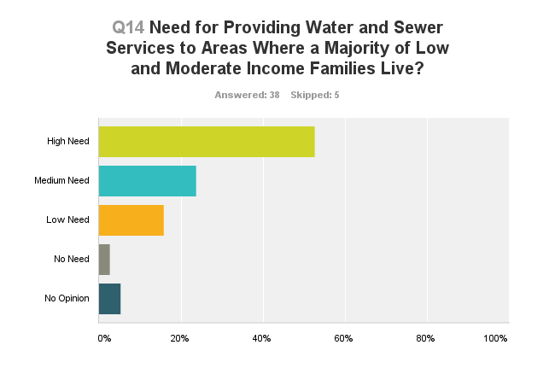
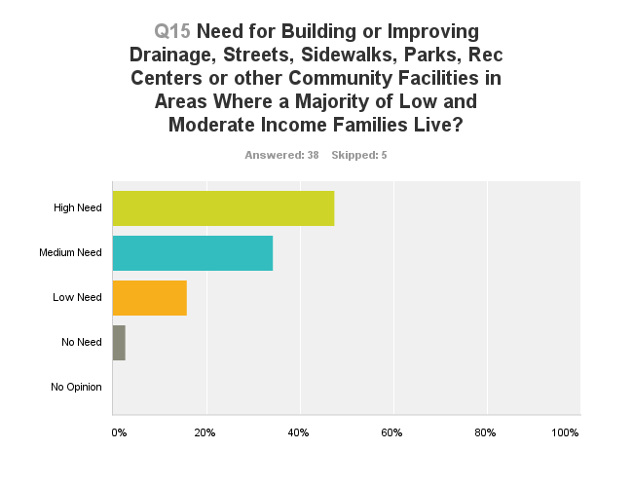
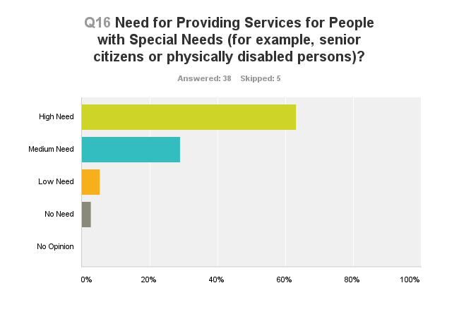
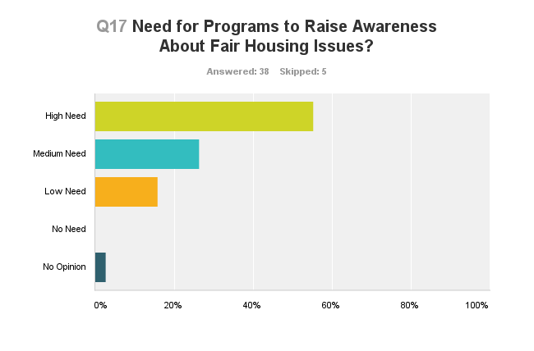
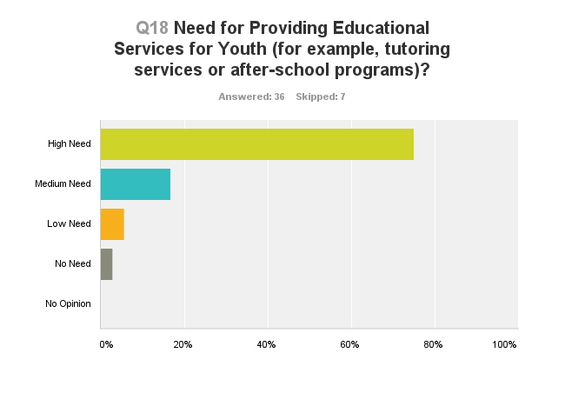
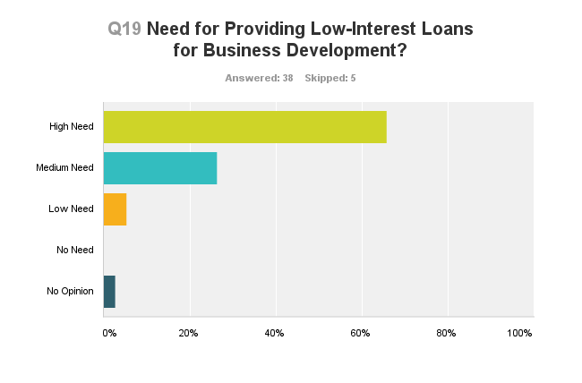
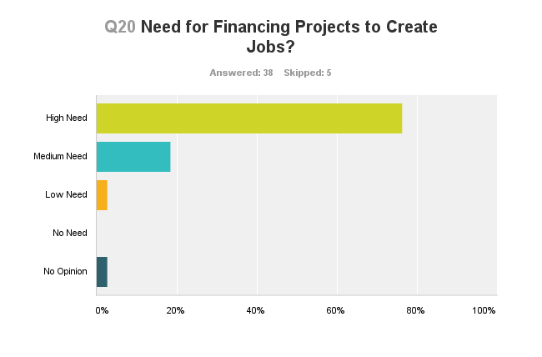
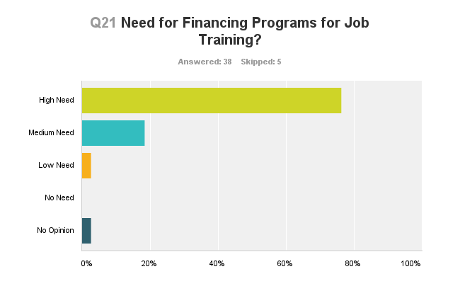

NA-10 Housing Needs Assessment
Summary of Housing Needs
Housing needs for the five-year planning period have primarily been determined based upon housing data provided by IDIS for the City of Anniston, along with supplemental housing data for the additional communities comprising the HOME Consortium (Hobson City, Calhoun County, Jacksonville, Piedmont and Weaver). Needs were estimated with regard to pertinent categories such as renter versus owner, elderly, small families, large families, disabled persons, and persons living with HIV/AIDS, as well as by federally-defined income categories of extremely low (<30% of median family income), low (30-50% of MFI), and moderate (50-80% of MFI) income. The new online format for the Consolidated Plan in IDIS (Integrated Data Information System) automatically generates housing data tables for the City of Anniston as the grantee. Data table were built using 2000 Census data, 2005-2009 American Community Survey (ACS) estimates, and 2005-2009 CHAS data.

One significant distinction with regard to this section of the plan is that Anniston’s CDBG and HOME programs cover two different jurisdictions, with CDBG funds targeted to Anniston only and HOME funds targeted to Anniston and five adjacent communities (Hobson City, Calhoun County, Jacksonville, Piedmont and Weaver). Subsequently, the Consolidated Plan format built into IDIS is not designed to address this issue and generates data tables for the City of Anniston only (as grantee). In an effort to address this issue, a general housing data table for the five adjacent HOME communities has been integrated into this needs analysis. This data is not identical in terms of the timeframe covered (2005-2009 for Anniston vs. 2007- 2011 for the HOME communities). CHAS (Comprehensive Housing Affordability Strategy) data is also not available for the HOME Consortium. We have, however, substituted comparable data that speaks to sub-populations, income levels (poverty), race, households and owner/renter breakouts in the remaining HOME Consortium communities. It is anticipated that this issue may be addressed in a future version of IDIS as more grantees come online to prepare and submit their planning documents as required by HUD effective October 2012.

For the purposes of this document, HUD-provided housing data for Anniston (automatically generated through IDIS) will be the primary data source analyzed to determine housing needs. Given that Anniston comprises a large percentage of the population residing in the HOME program jurisdiction, this analysis will take liberty in assuming that the housing needs and trends reflected within the City’s data is a significant sampling and representation of the needs and trends within the broader HOME jurisdiction.

Anniston Housing Demographics

According to the 2005-2009 American Community Survey (ACS) data provided by HUD, Anniston has a population of 23,550 individuals residing in 10,846 households. These levels reflect a 4% decrease in population and a 16% decrease in total households from the levels documented in the 2000 U.S. Census. However, during this same period, median income increased from $27,385 to $32,208, representing an 18% increase (See Table 5).
Demographics | 2000 Census (Base Year) | 2005-2009 ACS (Most Recent Year) | % Change
Population | 24,473 | 23,500 | -4%
Households | 12,894 | 10,846 | -16%
Median Income | $27,385.00 | $32,208 | 18%
Table 5 – Housing Needs Assessment Demographics

Data Source: 2005-2009 ACS Data
2000 Census (Base Year)
2005-2009 ACS (Most Recent Year)

Of the City’s 10,846 households, 5,410 (50%) fall into an income category that is within HUD’s income guidelines (0-80% of median family income), with 20% of households qualifying as being very-low income (<30% of MFI), 14% as low-income (30-50% of MFI) and 15.5% as moderate income (50-80% of MFI). At least one elderly person, age 62 and older, resides in 36% of households and 16% of households include a child age 6 or younger (See Table 6).

Number of Households Table
 | 0-30% HAMFI | >30-50% HAMFI | >50-80% HAMFI | >80-100% HAMFI | >100% HAMFI
Total Households * | 2,195 | 1,525 | 1,690 | 1,010
Small Family Households * | 585 | 425 | 480 | 2,455
Large Family Households * | 175 | 130 | 100 | 250
Household contains at least one person 62-74 years of age | 395 | 315 | 380 | 210 | 825
Household contains at least one person age 75 or older | 220 | 405 | 390 | 160 | 575
Households with one or more children 6 years old or younger * | 420 | 265 | 210 | 845

* the highest income category for these family types is >80% HAMFI
Table 6 - Total Households Table
Data Source: | 2005-2009 CHAS

HOME Communities Demographics (HOME Consortium Communities)

In addition to the analysis of housing needs in Anniston, an analysis was also conducted for the jurisdictions that comprise the HOME Consortium (Hobson City, Weaver, Jacksonville, Piedmont and Calhoun County - See Table 5a below). When all participating communities are combined, the HOME jurisdiction has an estimated population of 95,096 residents, representing a slight decrease (-1.4%) from the total population in 2000. This figure was calculated using the total population for Calhoun County (including Anniston) and subtracting the combined population of the two communities that opted not to participate in the HOME Consortium – Ohatchee and Oxford.

Individually, Hobson City’s population decreased by 12% and Piedmont’s decreased by 4.7%, while Jacksonville’s increased by nearly half (43.8%), and Weaver’s grew by 16%. With the exception of Weaver which has a median income of $39,586 and a poverty rate of 12.2%, all of the participating towns/cities had a median income level that was lower than the County’s ($39,467), and poverty rates that were higher than the County rate of 15.4% . Of particular note are Hobson City where nearly half (49.7%) of the population lives in poverty, with Piedmont ranking as the second highest poverty community at 34.8%.

Community | Population  2000 | Population  2007-2011 | Total  Housing Units/  Households | % Families  Living in Poverty | Median Income | Add’l.  Info
Hobson City | 878 | 771 (-12%)  13% - White  86% - Black  1% - Other  1.3% - Hisp. | 358 Units  296 HHs | 49.7%¹ | 22,033¹ | 59% of housing is owner occupied
Jacksonville | 8,404 | 12,090 (+43.8%)  72% - White  25% - Black  3% - Other  3.4% - Hisp. | 5,084 Units  4,525 HHs | 21.1% | $35,589 | 44% increase in population;  68% of renters vs. 23% of owners have hsg. costs >30% of income
Piedmont | 5,120 | 4,878 (-4.7%)  87% - White  10% - Black  3% - Other  1.3% - Hisp | 2,404 Units  2,053 HHs | 34.8%¹ | $28,301¹ | 68% of housing is owner occupied
Weaver | 2,619 | 3,038 (+16%)  81% - White  14% - Black  5% - Other  3% - Hisp. | 1,307 Units ²  1,166 HHs² | 12.2%³ | $39,586¹
Calhoun Co.  Ohatchee & Oxford)  Home Pop. | 112,249  15,807  (19% of Co. pop)  96,442 | 117,614 (+4.7%)  75.2% - White  20.5% - Black  4.3% - Other  3.2% - Hisp.  22,518 (+42%)  95,096 | 53,208 Units  45,932 HH’s  8,657 Units  8,546 HH’s | 15.4% | $39,467 | 70% of units are single family detached & owner occupied; 57% built before 1980; 50% renters income burdened (>30%)

Data Source: U.S. Census, ACS, 1 – City-Date.com, 2 – zip-codes.com, 3 - 2005-2009 ACS
Housing Needs Summary Tables for several types of Housing Problems
1. Housing Problems (Households with one of the listed needs)
 | Renter |  |  |  |  | Owner
 | 0-30% AMI | >30-50% AMI | >50-80% AMI | >80-100% AMI | Total | 0-30% AMI | >30-50% AMI | >50-80% AMI | >80-100% AMI | Total
Substandard Housing - Lacking complete plumbing or kitchen facilities | 0 | 0 | 0 | 0 | 0 | 10 | 0 | 0 | 0 | 10
Severely Overcrowded - With >1.51 people per room (and complete kitchen and plumbing) | 0 | 20 | 0 | 0 | 20 | 0 | 0 | 0 | 0 | 0
Overcrowded - With 1.01-1.5 people per room (and none of the above problems) | 10 | 15 | 20 | 0 | 45 | 15 | 30 | 0 | 0 | 45
Housing cost burden greater than 50% of income (and none of the above problems) | 735 | 320 | 15 | 0 | 1,070 | 325 | 160 | 65 | 55 | 605
Housing cost burden greater than 30% of income (and none of the above problems) | 260 | 265 | 220 | 0 | 745 | 165 | 195 | 375 | 65 | 800
Zero/negative Income (and none of the above problems) | 120 | 0 | 0 | 0 | 120 | 105 | 0 | 0 | 0 | 105
Table 7 – Housing Problems Table
Data Source: | 2005-2009 CHAS

2. Housing Problems 2 (Households with one or more Severe Housing Problems: Lacks kitchen or complete plumbing, severe overcrowding, severe cost burden)
 | Renter |  |  |  |  | Owner
 | 0-30% AMI | >30-50% AMI | >50-80% AMI | >80-100% AMI | Total | 0-30% AMI | >30-50% AMI | >50-80% AMI | >80-100% AMI | Total
Having 1 or more of four housing problems | 745 | 355 | 35 | 0 | 1,135 | 355 | 190 | 65 | 55 | 665
Having none of four housing problems | 520 | 490 | 575 | 385 | 1,970 | 350 | 490 | 1,015 | 575 | 2,430
Household has negative income, but none of the other housing problems | 120 | 0 | 0 | 0 | 120 | 105 | 0 | 0 | 0 | 105
Table 8 – Housing Problems 2
Data Source: | 2005-2009 CHAS

3. Cost Burden > 30%
 | Renter |  |  |  | Owner
 | 0-30% AMI | >30-50% AMI | >50-80% AMI | Total | 0-30% AMI | >30-50% AMI | >50-80% AMI | Total
Small Related | 340 | 245 | 75 | 660 | 150 | 100 | 145 | 395
Large Related | 110 | 65 | 0 | 175 | 15 | 20 | 25 | 60
Elderly | 140 | 100 | 55 | 295 | 245 | 200 | 145 | 590
Other | 415 | 175 | 105 | 695 | 110 | 50 | 120 | 280
Total need by income | 1,005 | 585 | 235 | 1,825 | 520 | 370 | 435 | 1,325
Table 9 – Cost Burden > 30%
Data Source: | 2005-2009 CHAS

4. Cost Burden > 50%
 | Renter |  |  |  | Owner
 | 0-30% AMI | >30-50% AMI | >50-80% AMI | Total | 0-30% AMI | >30-50% AMI | >50-80% AMI | Total
Small Related | 310 | 125 | 0 | 435 | 100 | 85 | 10 | 195
Large Related | 65 | 50 | 0 | 115 | 0 | 0 | 15 | 15
Elderly | 60 | 40 | 0 | 100 | 175 | 55 | 10 | 240
Other | 310 | 100 | 15 | 425 | 65 | 20 | 30 | 115
Total need by income | 745 | 315 | 15 | 1,075 | 340 | 160 | 65 | 565
Table 10 – Cost Burden > 50%
Data Source: | 2005-2009 CHAS

5. Crowding (More than one person per room)
 | Renter |  |  |  |  | Owner
 | 0-30% AMI | >30-50% AMI | >50-80% AMI | >80-100% AMI | Total | 0-30% AMI | >30-50% AMI | >50-80% AMI | >80-100% AMI | Total
Single family households | 10 | 4 | 10 | 0 | 24 | 15 | 20 | 0 | 0 | 35
Multiple, unrelated family households | 0 | 24 | 10 | 0 | 34 | 0 | 10 | 0 | 0 | 10
Other, non-family households | 0 | 0 | 0 | 0 | 0 | 0 | 0 | 0 | 0 | 0
Total need by income | 10 | 28 | 20 | 0 | 58 | 15 | 30 | 0 | 0 | 45
Table 11 – Crowding Information
Data Source: | 2005-2009 CHAS

What are the most common housing problems?
Housing data provides clear evidence that the most common housing problem is cost overburden for both renters and owners, with renters primarily having a burden of greater than 50% and owners having a burden of 30% (See Table 7).

Are any populations/household types more affected than others by these problems?
Not surprisingly, very low income (<30% of MFI) and low income (30-50% of MFI) families that rent appear to be disproportionately burdened by housing costs with over 1,000 families have a cost burden greater than 50% of their household income.
Describe the characteristics and needs of Low-income individuals and families with children (especially extremely low-income) who are currently housed but are at imminent risk of either residing in shelters or becoming unsheltered 91.205(c)/91.305(c)). Also discuss the needs of formerly homeless families and individuals who are receiving rapid re-housing assistance and are nearing the termination of that assistance
Nearly one-fifth (19.1%) of very low income households are occupied by families with children under age six (See Table 6). These households also tend to be occupied by African Americans who disproportionately report one or more housing needs and/or severe housing needs, putting them at high risk for homelessness. Similarly, formerly homeless families who are nearing the end of their rapid re-housing assistance are also at high risk of falling into homelessness again. To prevent this regression, families need job training and employment assistance to obtain living-wage jobs, as well as daycare and transportation assistance to support employment.
If a jurisdiction provides estimates of the at-risk population(s), it should also include a description of the operational definition of the at-risk group and the methodology used to generate the estimates:
The Point-in-Time (PIT) Count is an annual survey of homeless persons and agencies that serve the homeless to generate estimates of the number of homeless persons residing in the area. The PIT for the Calhoun County is conducted in January of each year covering both Calhoun and Etowah Counties. It is a volunteer effort led by the staff of Jacksonville State University’s Department of Social Work and Sociology and conducted by students majoring in these fields. The most recently completed 2013 PIT report, estimates that there were 399 homeless individuals in the area during the last count. This total represents a pattern of increasing numbers of homeless persons since 2007 (2011/390, 2010/370, 2009/301, 2008/298, and 2007/276)

The five-step methodology was used to generate the estimate. In order, they are:
- Sites chosen for the 2012 survey were based on participation the prior year
- Churches and community groups who provide meals, shelter or food banks were encouraged to complete both individual and agency surveys.
- Participation was voluntary
- Efforts were made to reach the unsheltered homeless in the community.
- JSU students went in teams to congregate housing and meal sites. Students also contacted agencies to complete the agency annual data.
The survey uses the operational definitions established by HCNEA, the regional CoC:
Homeless Person or Homeless Individuals:
- An individual who lacks a fixed, regular and adequate nighttime residence, and
- An individual who has a primary nighttime residence that is:
  - A supervised publicly or privately operated shelter designed to provide temporary living accommodations (including welfare hotels, congregate shelters and transitional housing for the mentally ill);
  - An institution that provides a temporary residence for individuals intended to be institutionalized; or
  - A public or private place not designed for, or ordinarily used as, a regular sleeping accommodation for human beings.
Chronic Homelessness: An unaccompanied homeless individual with a disabling condition who has either been continuously homeless for a year or more OR has had at least four (4) episodes of homelessness in the past three years. To be considered chronically homeless persons must have been sleeping in a place not meant for human habitation (e.g. living on the streets) and/or in an emergency homeless shelter during that time. This group represents 10% of the homeless population, but consumes 50% of the resources designed to support the homeless.
Unaccompanied Homeless Individual: A single person who is alone. This individual is not part of a homeless family and/or is not accompanied by a child or children
Disabling Condition: A diagnosable substance use disorder, serious mental illness, developmental disability, or chronic physical illness or disability, including the co-occurrence of two or more of these conditions. A disabling condition limits an individual’s ability to work or perform one or more activities of daily living.

Specify particular housing characteristics that have been linked with instability and an increased risk of homelessness
According to the data on homelessness compiled by Jacksonville State University for HCNEA, the top five reasons for homelessness given by survey respondents were: 1) Unemployment; 2) Substance Abuse; 3) Income Too Low; 4) Recently in Jail; and 5) Domestic Violence.

NA-15 Disproportionately Greater Need: Housing Problems
Assess the need of any racial or ethnic group that has disproportionately greater need in comparison to the needs of that category of need as a whole.
With regard to race and ethnicity, low and very low-income, African Americans households demonstrate a disproportionately higher rate of housing problems. Of the 1,520 very low income households that reported at least one housing problem, 92.4% were African American and for low-income households, approximately two-thirds (64%) were African American (See Tables 12 and 13).
0%-30% of Area Median Income
Housing Problems | Has one or more of four housing problems | Has none of the four housing problems | Household has no/negative income, but none of the other housing problems
Jurisdiction as a whole | 1,520 | 445 | 225
White | 405 | 155 | 85
Black / African American | 1,045 | 245 | 130
Asian | 0 | 50 | 0
American Indian, Alaska Native | 0 | 0 | 0
Pacific Islander | 0 | 0 | 0
Hispanic | 55 | 0 | 10
Table 12 - Disproportionally Greater Need 0 - 30% AMI
Data Source: | 2005-2009 CHAS

*The four housing problems are:
1. Lacks complete kitchen facilities, 2. Lacks complete plumbing facilities, 3. More than one person per room, 4.Cost Burden greater than 30%

30%-50% of Area Median Income
Housing Problems | Has one or more of four housing problems | Has none of the four housing problems | Household has no/negative income, but none of the other housing problems
Jurisdiction as a whole | 1,000 | 520 | 0
White | 350 | 310 | 0
Black / African American | 640 | 215 | 0
Asian | 0 | 0 | 0
American Indian, Alaska Native | 0 | 0 | 0
Pacific Islander | 0 | 0 | 0
Hispanic | 10 | 0 | 0
Table 13 - Disproportionally Greater Need 30 - 50% AMI
Data Source: | 2005-2009 CHAS

*The four housing problems are:
1. Lacks complete kitchen facilities, 2. Lacks complete plumbing facilities, 3. More than one person per room, 4.Cost Burden greater than 30%

50%-80% of Area Median Income
Housing Problems | Has one or more of four housing problems | Has none of the four housing problems | Household has no/negative income, but none of the other housing problems
Jurisdiction as a whole | 690 | 990 | 0
White | 330 | 420 | 0
Black / African American | 330 | 505 | 0
Asian | 20 | 0 | 0
American Indian, Alaska Native | 0 | 0 | 0
Pacific Islander | 0 | 0 | 0
Hispanic | 10 | 10 | 0
Table 14 - Disproportionally Greater Need 50 - 80% AMI
Data Source: | 2005-2009 CHAS

*The four housing problems are:
1. Lacks complete kitchen facilities, 2. Lacks complete plumbing facilities, 3. More than one person per room, 4.Cost Burden greater than 30%
80%-100% of Area Median Income
Housing Problems | Has one or more of four housing problems | Has none of the four housing problems | Household has no/negative income, but none of the other housing problems
Jurisdiction as a whole | 120 | 890 | 0
White | 85 | 415 | 0
Black / African American | 35 | 465 | 0
Asian | 0 | 0 | 0
American Indian, Alaska Native | 0 | 0 | 0
Pacific Islander | 0 | 0 | 0
Hispanic | 0 | 0 | 0
Table 15 - Disproportionally Greater Need 80 - 100% AMI
Data Source: | 2005-2009 CHAS

*The four housing problems are:
1. Lacks complete kitchen facilities, 2. Lacks complete plumbing facilities, 3. More than one person per room, 4.Cost Burden greater than 30%

NA-20 Disproportionately Greater Need: Severe Housing Problems
Assess the need of any racial or ethnic group that has disproportionately greater need in comparison to the needs of that category of need as a whole.
With regard to severe housing problems (lacks complete kitchen, lacks complete plumbing facilities, more than 1.5 persons per room or cost overburden >50%), low and very-low income, African American households again demonstrate disproportionate need with a rate of 63.1% and 70.6% respectively (See Tables 16 and 17).

0%-30% of Area Median Income
Housing Problems | Has one or more of four housing problems | Has none of the four housing problems | Household has no/negative income, but none of the other housing problems
Jurisdiction as a whole | 1,100 | 870 | 225
White | 330 | 230 | 85
Black / African American | 695 | 590 | 130
Asian | 0 | 50 | 0
American Indian, Alaska Native | 0 | 0 | 0
Pacific Islander | 0 | 0 | 0
Hispanic | 55 | 0 | 10
Table 16 – Severe Housing Problems 0 - 30% AMI
Data Source: | 2005-2009 CHAS

*The four severe housing problems are:
1. Lacks complete kitchen facilities, 2. Lacks complete plumbing facilities, 3. More than 1.5 persons per room, 4.Cost Burden over 50%

30%-50% of Area Median Income
Housing Problems | Has one or more of four housing problems | Has none of the four housing problems | Household has no/negative income, but none of the other housing problems
Jurisdiction as a whole | 545 | 980 | 0
White | 145 | 510 | 0
Black / African American | 385 | 470 | 0
Asian | 0 | 0 | 0
American Indian, Alaska Native | 0 | 0 | 0
Pacific Islander | 0 | 0 | 0
Hispanic | 10 | 0 | 0
Table 17 – Severe Housing Problems 30 - 50% AMI
Data Source: | 2005-2009 CHAS

*The four severe housing problems are:
1. Lacks complete kitchen facilities, 2. Lacks complete plumbing facilities, 3. More than 1.5 persons per room, 4.Cost Burden over 50%

50%-80% of Area Median Income
Housing Problems | Has one or more of four housing problems | Has none of the four housing problems | Household has no/negative income, but none of the other housing problems
Jurisdiction as a whole | 100 | 1,590 | 0
White | 75 | 675 | 0
Black / African American | 25 | 810 | 0
Asian | 0 | 20 | 0
American Indian, Alaska Native | 0 | 0 | 0
Pacific Islander | 0 | 0 | 0
Hispanic | 0 | 20 | 0
Table 18 – Severe Housing Problems 50 - 80% AMI
Data Source: | 2005-2009 CHAS

*The four severe housing problems are:
1. Lacks complete kitchen facilities, 2. Lacks complete plumbing facilities, 3. More than 1.5 persons per room, 4.Cost Burden over 50%

80%-100% of Area Median Income
Housing Problems | Has one or more of four housing problems | Has none of the four housing problems | Household has no/negative income, but none of the other housing problems
Jurisdiction as a whole | 55 | 960 | 0
White | 55 | 450 | 0
Black / African American | 0 | 500 | 0
Asian | 0 | 0 | 0
American Indian, Alaska Native | 0 | 0 | 0
Pacific Islander | 0 | 0 | 0
Hispanic | 0 | 0 | 0
Table 19 – Severe Housing Problems 80 - 100% AMI
Data Source: | 2005-2009 CHAS

*The four severe housing problems are:
1. Lacks complete kitchen facilities, 2. Lacks complete plumbing facilities, 3. More than 1.5 persons per room, 4.Cost Burden over 50%

NA-25 Disproportionately Greater Need: Housing Cost Burdens
Assess the need of any racial or ethnic group that has disproportionately greater need in comparison to the needs of that category of need as a whole.
Among households with a housing cost burden greater than 30%, African Americans again demonstrate their disproportionate representation within this group (See Table 20).

Housing Cost Burden
Housing Cost Burden | <=30% | 30-50% | >50% | No / negative income (not computed)
Jurisdiction as a whole | 7,150 | 1,760 | 1,695 | 225
White | 4,195 | 695 | 585 | 85
Black / African American | 2,715 | 1,040 | 1,030 | 130
Asian | 110 | 20 | 0 | 0
American Indian, Alaska Native | 10 | 0 | 0 | 0
Pacific Islander | 0 | 0 | 0 | 0
Hispanic | 55 | 10 | 65 | 10
Table 20 – Greater Need: Housing Cost Burdens AMI
Data Source: | 2005-2009 CHAS

NA-30 Disproportionately Greater Need: Discussion
Income categories in which a racial or ethnic group has disproportionately greater need
Very low and low income African American households consistently demonstrate a disproportionately greater need for housing assistance.

Needs not previously identified
Table 10 provides evidence that the following populations and households types also have a housing cost burden greater than 50%: 1) very low and low income renter households occupied by disabled persons (defined as other), 2) very low and low income renter households occupied by small related families; and 3) the elderly in very low income, owner-occupied households.

Are any of those racial or ethnic groups located in specific areas or neighborhoods in your community?
Within the City of Anniston, African Americans heavily reside in West Anniston. There is also a high concentration in Hobson City where African Americans make up 86% of the total population (See Attached Maps). Census data also indicates that low-to-moderate income households in Calhoun County are located in the following census tracts and block groups:

Census Tract | Block Group | Census Tract | Block Group
1 | 2 | 3 | 1
3 | 2 | 4 | 1
4 | 2 | 5 | 1
5 | 2 | 6 | 1
6 | 2 | 8 | 1
12 | 1 | 13 | 1
13 | 2 | 14 | 1
16 | 4 | 18 | 1
20 | 4 | 21.01 | 2
21.02 | 3 | 21.03 | 1
21.03 | 2 | 22 | 3
23 | 3 | 23 | 4

NA-35 Public Housing
Totals in Use
Program Type
 | Certificate | Mod-Rehab | Public Housing
 |  |  |  | Total | Project -based | Tenant -based | Special Purpose Voucher
 |  |  |  |  |  |  | Veterans Affairs Supportive Housing | Family Unification Program | Disabled  *
# of units vouchers in use | 0 | 0 | 699 | 205 | 0 | 205 | 0 | 0 | 0

*includes Non-Elderly Disabled, Mainstream One-Year, Mainstream Five_year, and Nursing Home Transition
Table 21 - Public Housing by Program Type
Data Source: | PIC (PIH Information Center)

Characteristics of Residents
Program Type
 | Certificate | Mod-Rehab | Public Housing
 |  |  |  | Total | Project -based | Tenant -based | Special Purpose Voucher
 |  |  |  |  |  |  | Veterans Affairs Supportive Housing | Family Unification Program | Disabled  *
Average Annual Income | 0 | 0 | 6,474 | 10,744 | 0 | 10,744 | 0 | 0 | 0
Average length of stay | 0 | 0 | 4 | 5 | 0 | 5 | 0 | 0 | 0
Average Household size | 0 | 0 | 2 | 2 | 0 | 2 | 0 | 0 | 0
# Homeless at admission | 0 | 0 | 16 | 0 | 0 | 0 | 0 | 0 | 0
# of Elderly Program Participants (>62) | 0 | 0 | 38 | 44 | 0 | 44 | 0 | 0 | 0
# of Disabled Families | 0 | 0 | 113 | 61 | 0 | 61 | 0 | 0 | 0
# of Families requesting accessibility features | 0 | 0 | 699 | 205 | 0 | 205 | 0 | 0 | 0
# of HIV/AIDS program participants | 0 | 0 | 0 | 0 | 0 | 0 | 0 | 0 | 0
# of DV victims | 0 | 0 | 0 | 0 | 0 | 0 | 0 | 0 | 0

*includes Non-Elderly Disabled, Mainstream One-Year, Mainstream Five_year, and Nursing Home Transition
Table 22 – Characteristics of Public Housing Residents by Program Type
Data Source: | PIC (PIH Information Center)

Race of Residents
Program Type
Race | Certificate | Mod-Rehab | Public Housing
 |  |  |  | Total | Project -based | Tenant -based | Special Purpose Voucher
 |  |  |  |  |  |  | Veterans Affairs Supportive Housing | Family Unification Program | Disabled  *
White | 0 | 0 | 23 | 23 | 0 | 23 | 0 | 0 | 0
Black/African American | 0 | 0 | 673 | 181 | 0 | 181 | 0 | 0 | 0
Asian | 0 | 0 | 2 | 0 | 0 | 0 | 0 | 0 | 0
American Indian/Alaska Native | 0 | 0 | 1 | 0 | 0 | 0 | 0 | 0 | 0
Pacific Islander | 0 | 0 | 0 | 1 | 0 | 1 | 0 | 0 | 0
Other | 0 | 0 | 0 | 0 | 0 | 0 | 0 | 0 | 0

*includes Non-Elderly Disabled, Mainstream One-Year, Mainstream Five_year, and Nursing Home Transition
Table 23 – Race of Public Housing Residents by Program Type
Data Source: | PIC (PIH Information Center)

Ethnicity of Residents
Program Type
Race | Certificate | Mod-Rehab | Public Housing
 |  |  |  | Total | Project -based | Tenant -based | Special Purpose Voucher
 |  |  |  |  |  |  | Veterans Affairs Supportive Housing | Family Unification Program | Disabled  *
Hispanic | 0 | 0 | 3 | 0 | 0 | 0 | 0 | 0 | 0
Not Hispanic | 0 | 0 | 696 | 205 | 0 | 205 | 0 | 0 | 0

*includes Non-Elderly Disabled, Mainstream One-Year, Mainstream Five_year, and Nursing Home Transition
Table 24 – Ethnicity of Public Housing Residents by Program Type
Data Source: | PIC (PIH Information Center)

Section 504 Needs Assessment
A review of the HUD-provided data in Tables 21 and 22 reveals that the Anniston Housing Authority has 699 public housing units available and 205 Housing Choice Vouchers. Of these totals, 113 units (16%) are occupied by and 61 vouchers (29.7%) are used by disabled persons, while 100% of units and vouchers were requested by families desiring accessibility features.

All available data indicate that the area’s public housing units are in compliance with Section 504 requirements for accessibility for persons with disabilities. There are currently no plans to address any problems that exist with regard to public housing. However, the Executive Director of the Anniston Housing Authority actively participated in the CP process and emphasized the need for the strategic targeting of federal funds for greater community impact.

Needs of public housing tenants and applicants on the waiting list for accessible units
According to the Clear Plan 2030 Existing Conditions Report prepared by the East Alabama Regional Planning and Development Commission in the summer of 2012, there are four public housing authorities (PHAs) located in Calhoun County - Anniston, Hobson City, Jacksonville and Piedmont. Anniston and Jacksonville have Housing Choice Voucher Programs and the
average waitlist time is two years and one and a half years respectively (Source: Birmingham HUD Field Office and Telephone Survey). The data provided above in combination with a nearly 100% occupancy rate and an average wait time of two years, indicated the increased need for accessible housing.

PHA | HCV Program | # of Public Housing Units | # of Public Housing Residents | Occupancy Rate as of 3/31/13 | # Housing Choice Vouchers | # Housing Choice Residents
Anniston | Yes | 748 | 1,581 | 97.6% | 258 | 438
Hobson City | No | 60 | 150 | 98.3% | N/A | N/A
Jacksonville | Yes | 175 | 335 | 100% | 214 | 316
Piedmont | No | 211 | 451 | 100% | N/A | N/A
Total |  | 1,194 | 2,517 | 99% | 472 | 754

Most immediate needs of residents of Public Housing and Housing Choice voucher holders
The most immediate needs for residents of public housing and housing choice vouchers holders are reduced waiting times to access affordable housing and a better understand of fair housing issues, particularly for voucher holders who must secure housing on the private market.

How do these needs compare to the housing needs of the population at large
Based on the high percentage of households in the general population with high housing burden costs, the need for improved access to affordable housing and an improved understanding of fair housing issues are comparable to the needs of public housing residents and voucher holders.

NA-40 Homeless Needs Assessment
Homeless Needs Assessment
Population | Estimate the # of persons experiencing homelessness on a given night |  | Estimate the # experiencing homelessness each year | Estimate the # becoming homeless each year | Estimate the # exiting homelessness each year | Estimate the # of days persons experience homelessness
 | Sheltered | Unsheltered
Persons in Households with Adult(s) and Child(ren) | 98 | 26
Persons in Households with Only Children | 4 | 0
Persons in Households with Only Adults | 227 | 44
Chronically Homeless Individuals | 10 | 10
Chronically Homeless Families | 10 | 10
Veterans | 26 | 5
Unaccompanied Child | 10 | 1
Persons with HIV | 6 | 0
Table 25 - Homeless Needs Assessment

Jurisdiction’s Rural Homeless Population
For persons in rural areas who are homeless or at risk of homelessness, describe the nature and extent of unsheltered and sheltered homelessness with the jurisdiction
The City of Anniston is not comprised of any rural areas and Calhoun is a largely urban county with 69% of the population estimated to be urban and 31% rural. Therefore, a small percentage of the area’s homeless are in rural communities and typically in sheltered rather than unsheltered environments.
The Alabama Rural Coalition for the Homeless (ARCH) is the Balance of State CoC that serves 42 rural counties statewide. Calhoun County is not included within its jurisdiction.
If data is not available for the categories "number of persons becoming and exiting homelessness each year," and "number of days that persons experience homelessness," describe these categories for each homeless population type (including chronically homeless individuals and families, families with children, veterans and their families, and unaccompanied youth):
Based upon 2013 PIT survey data, there were 399 homeless persons in the area, of which 10 were children under the age of 18 years old, 59 were young adults between the ages of 18 and 24, and 330 were adults age 25 and older. Only 5% (20 individuals) were identified as being chronically homeless, 7.7% (31 individuals) were veterans, 20% (80 individuals) had a chronic substance abuse problem, 14% (54 individuals) were severely mentally ill, 6.7% were victims of domestic violence, and 1.5% were individuals living with HIV/AIDS. The large majority of individuals (82%) self-reported as having access to emergency or transitional shelter.

Nature and Extent of Homelessness by Racial and Ethnic Group
According to the 2012 PIT Survey Report, approximately 41% of homeless persons are Black, 58% are White, and 1% is Hispanic. These rates are reported to have been constant since 2007. The overall nature of homelessness in the area tends to be emergency based rather than chronic.

Nature and Extent of Unsheltered and Sheltered Homelessness, including Rural Homelessness
The majority of survey respondents (82%) classified themselves as sheltered homeless with 40% indicating they stayed in an emergency shelter the night before, 42% reporting they had access to transitional shelter (stayed with a friend or relative), and 18% reporting that they were unsheltered (slept on the street). Calhoun County is 61% urban, therefore the large majority of homeless persons are located in urban areas.

NA-45 Non-Homeless Special Needs Assessment

Characteristics of Special Needs Populations
Special needs populations include the elderly, physically and mentally disabled persons and persons living with HIV/AIDS. Estimates of the number of persons within these categories and living in Anniston and Calhoun County are shown below:

Population with Special Needs | Anniston | Calhoun County
Persons living with HIV/AIDS¹ | N/A | 323
Elderly (Age 65+)² | 4,096 (17.7%) | 16,990 (14.3%)
Disabled (mentally and/or physically)³ | 5,059 (22.7%) | 21,691 (18.3%)
Source: 1-AL Dept. of Health; 2-2010 Census; 3-2009-2011 ACS data

Housing and Supportive Service Needs and Determination
According to the Alabama Department of Public Health, there were 323 people in Calhoun County living with HIV/AIDS as of the end of 2012. AIDS Alabama is the HOPWA formula grantee of record and is the statewide HOPWA provider, while the Health Services Center (HSC) is the regional provider of care for this population. AIDS Alabama provides funding annually to Health Services Center (HSC) for short-term rental and mortgage assistance; long-term rental assistance; and supplemental housing case management. Through a direct HOPWA grant from HUD, HSC provides six units of transitional housing and substance abuse treatment for persons living with aids and for those at risk; including homeless persons. Mental health services and medical care are available through other federal grant resources.

Primary housing needs identified for persons living with AIDS are permanent supportive housing, housing information and referrals, permanent housing placement, and emergency/short-term shelter. Another critical component for all services and for continued efficacy in the housing continuum is the need for intensive and continuous case management.

Public Size and Characteristics of Population with HIV / AIDS
Data listed within the Alabama Department of Public Health’s (ADPH) 2012 Public Health Area Report shows that Calhoun County has 323 cumulative cases of persons living with HIV/AIDS as of December 31, 2012. This figure includes the 14 newly diagnosed individuals who reported in calendar year 2011, as well as the 14 persons reported in 2012. According to ADPH’s 2011 HIV Epidemiological Profile, Calhoun County had 12 (1.7%) of the 707 new HIV diagnoses in Alabama in 2011. New infections are disproportionately occurring in the African American population, as well as in young adults under age 35. Although African Americans comprised only 26% of the state’s population in 2011, they represented 68% of newly diagnosed HIV infections. Health Services Center, Inc. is the sole supportive service agency with a mission of meeting the needs of persons living with HIV/AIDS in Calhoun County.

NA-50 Non-Housing Community Development Needs
Public Facilities - Need Determination
The need for improvements to public facilities was identified as a priority primarily through agency consultations and requests for funding assistance. One public facilities improvement project is included within Year 1 of this Five Year Consolidated Plan. CDBG funding has been allocated in the amount of $210,000 to improve an existing building (Unified Resources Center) that will be used for the provision of community services.

Year 1 Recommended Project: Unified Resources Center - $210,000

Public Improvements - Need Determination
Public infrastructure improvements have not been identified as a high priority at this time and no CDBG funds have been allocated in Year 1 for this purpose. However, the possible future use of CDBG funding for this purpose remains high. Planned investments by the Anniston Board of Education in West Anniston, as well as strategic planning efforts underway at the Anniston Housing Authority may necessitate the use of funds for this purpose within the five-year planning period.

Public Services - Need Determination
Public services needs were determined based on community feedback during public hearings, consultations with service providers, feedback from the community needs assessment survey and requests for CDBG funding via an Application for Public Services Funding issued by the City. Ten applications for funding were received totaling $149,315.16. Nine of the requests were recommended for funding under the 15% Public Services cap which is $81,399 for Year 1.

Year 1 Recommended Projects:
Boys and Girls Club of East Central AL $6,000
Independent Reading & Counseling Services $5,000
2nd Chance, Inc. $6,000
St. Michael's Community Service Center $22,000
Pre School Friends $3,000
Children's Services, Inc. $3,500
Anniston Soup Bowl $6,000
Community Enabler Developer Inc. $6,000
West Anniston Foundation $2,500
Anniston Youth Employment Program $21,399
$81,399

Housing Market Analysis

MA-05 Overview
Housing Market Analysis Overview:
Anniston’s housing market consists of 13,236 residential housing units. Three-fourths of the market is made up of single-family housing, with 71% being standalone detached units and 4% being attached. Multi-family housing (2+ units) comprises 25% of the market (See Table 28). A much larger percentage of housing is vacant in Anniston (20%) than in Calhoun County (13%)

Based on 2005-2009 ACS data, the median home value is $91,900 and the median rent is $380, an increase of 37% and 36% respectively since 2000 (See Table 30). Approximately 75% of those who rent pay less than $500 per month, with the remaining quarter paying $500 to $100. Less than one-half of one percent of the population pays $2,000 or more per month (See Table 31).

For very low-income renter households, only 14% of affordable units were available, while nearly a third were available to low-income households and over half were available to moderate income renters. For very low income owner households, 22% of affordable units were available, while nearly a third were available to moderate income households (See Table 32). Fair market rent (FMR) ranged from a low of $463 for an efficiency to $885 for a four bedroom unit. The FMR for the average sized 2 bedroom unit was $636 (See Table 33).

Anniston has an aging housing market with 75% of owner and renter occupied housing being built before 1980, which is also an indicator of a high likelihood of the presence of lead-based paint hazards. Approximately, 5% of units on the housing market have been built since 2000 (See Table 35). This trend documents the need for increased housing development activity, especially with regard to affordable housing.

In terms of the condition of housing, renters report at least one housing condition at a rate that is almost twice that of owners (43% vs. 23), which is an indicator than renters have a higher need not only for housing that is affordable, but also decent.

MA-10 Number of Housing Units
Introduction
All residential properties by number of units
Property Type | Number | %
1-unit detached structure | 9,359 | 71%
1-unit, attached structure | 517 | 4%
2-4 units | 1,330 | 10%
5-19 units | 1,274 | 10%
20 or more units | 659 | 5%
Mobile Home, boat, RV, van, etc. | 97 | 1%
Total | 13,236 | 100%
Table 28 – Residential Properties by Unit Number
Data Source: | 2005-2009 ACS Data

Unit Size by Tenure
 | Owners |  | Renters
 | Number | % | Number | %
No bedroom | 0 | 0% | 30 | 1%
1 bedroom | 97 | 1% | 1,090 | 25%
2 bedrooms | 1,210 | 19% | 1,802 | 42%
3 or more bedrooms | 5,202 | 80% | 1,415 | 33%
Total | 6,509 | 100% | 4,337 | 101%
Table 29 – Unit Size by Tenure
Data Source: | 2005-2009 ACS Data

Number and Targeting of Units
ACS data shows that Anniston has 13,236 residential units of which 75% is single-family housing (See Table 28). Among owners, 80% of units are comprised of 3 or more bedrooms, while just less than half of rental units (42) have two bedrooms and one-third of units have three or more bedrooms. CDBG funds will be used to conduct rehabilitation activities on both single and multi-family housing units citywide.
Units Expected to be lost from Inventory
Based on input from the City of Anniston’s code enforcement staff, a small amount of CDBG funding ($62,696) has been allocated for slums and blight removal through the demolition of condemned housing that has been determined to be a public nuisance. It is estimated that approximately six housing units will be demolished in Year 1.

Does the availability of housing units meet the needs of the population?
There is a documented need for affordable housing Anniston and in the communities that comprise that HOME Consortium, especially for low income renters. There is also a need for transitional and permanent housing for homeless persons.

Need for Specific Types of Housing
Based on the housing and housing market analysis, the need for the following types of housing has been identified:

- Affordable single family housing for very low and low income households
- Affordable multi-family housing for very low and low income renters
- Transitional and permanent housing for the homeless

Discussion

MA-15 Cost of Housing
Cost of Housing
 | 2000 Census (Base Year) | 2005-2009 ACS (Most Recent Year) | % Change
Median Home Value | 67,200 | 91,900 | 37%
Median Contract Rent | 280 | 380 | 36%
Table 30 – Cost of Housing
Data Source: | 2005-2009 ACS Data
2000 Census (Base Year)
2005-2009 ACS (Most Recent Year)

Rent Paid | Number | %
Less than $500 | 3,284 | 75.7%
$500-999 | 1,038 | 23.9%
$1,000-1,499 | 0 | 0.0%
$1,500-1,999 | 0 | 0.0%
$2,000 or more | 15 | 0.4%
Total | 4,337 | 100.0%
Table 31 - Rent Paid
Data Source: | 2005-2009 ACS Data

Housing Affordability
% Units affordable to Households earning | Renter | Owner
30% HAMFI | 725 | No Data
50% HAMFI | 1,650 | 1,095
80% HAMFI | 2,720 | 1,590
100% HAMFI | No Data | 2,320
Total | 5,095 | 5,005
Table 32 – Housing Affordability
Data Source: | 2005-2009 CHAS

Monthly Rent
Monthly Rent ($) | Efficiency (no bedroom) | 1 Bedroom | 2 Bedroom | 3 Bedroom | 4 Bedroom
Fair Market Rent | $463 | $484 | $636 | $822 | $885
High HOME Rent | $463 | $484 | $597 | $690 | $770
Low HOME Rent | $463 | $484 | $636 | $822 | $855
Table 33 – Monthly Rent
Data Source: | 2013 HUD FMR and HOME Rents

Availability of Sufficient Housing
Among owner-occupied households, 75% reported no housing conditions, while for renter households less than half (43%) reported no housing conditions. This data is a strong indication that increasing the availability of affordable housing, especially rental housing, that is decent and safe is a high priority.

Expected Change of Housing Affordability
Since 2000, median mortgage and contract rent have both increased by almost 40%. Due to the poor economy, wages have certainly not risen at the same pace. This trend of increase is another indicator that housing may become even less affordable as time passes.

Rent Comparison
According to the ACS data in Table 31, over three-fourths (75.7%) of the renter population pays less than $500. When compared to HOME fair market rents (See Table 33), this amount is affordable for only up to a one bedroom apartment. This data is an indication that rental housing is not affordable for families, which would require, at minimum, a t two bedroom apartment.

MA-20 Condition of Housing
Definitions
Condition of Units
Condition of Units | Owner-Occupied |  | Renter-Occupied
 | Number | % | Number | %
With one selected Condition | 1,593 | 24% | 1,880 | 43%
With two selected Conditions | 37 | 1% | 25 | 1%
With three selected Conditions | 0 | 0% | 0 | 0%
With four selected Conditions | 0 | 0% | 0 | 0%
No selected Conditions | 4,879 | 75% | 2,432 | 56%
Total | 6,509 | 100% | 4,337 | 100%
Table 34 - Condition of Units
Data Source: | 2005-2009 ACS Data

Year Unit Built
Year Unit Built | Owner-Occupied |  | Renter-Occupied
 | Number | % | Number | %
2000 or later | 290 | 4% | 201 | 5%
1980-1999 | 1,328 | 20% | 908 | 21%
1950-1979 | 3,119 | 48% | 2,193 | 51%
Before 1950 | 1,772 | 27% | 1,035 | 24%
Total | 6,509 | 99% | 4,337 | 101%
Table 35 – Year Unit Built
Data Source: | 2005-2009 CHAS

Risk of Lead-Based Paint Hazard
Risk of Lead-Based Paint Hazard | Owner-Occupied |  | Renter-Occupied
 | Number | % | Number | %
Total Number of Units Built Before 1980 | 4,891 | 75% | 3,228 | 74%

Housing Units build before 1980 with children present | 1,120 | 17% | 385
Table 36 – Risk of Lead-Based Paint
Data Source: | 2005-2009 ACS (Total Units) 2005-2009 CHAS (Units with Children present)

Vacant Units
 | Suitable for Rehabilitation | Not Suitable for Rehabilitation | Total
Vacant Units  Anniston  Calhoun County | N/A | N/A | 2,504 (20.4%)  7,285 (13.7%)
Abandoned Vacant Units | N/A | N/A | N/a
REO Properties  Anniston  Calhoun County | N/A | N/A | 2  15
Abandoned REO Properties | N/A | N/A | N/A
Table 37 - Vacant Units

Need for Owner and Rental Rehabilitation
The need for owner and rental rehabilitation assistance has been documented and CDBG funds have been allocated to provide assistance to LMI homeowners and owners of multi-family housing occupied by LMI renters.

Estimated Number of Housing Units Occupied by Low or Moderate Income Families with LBP Hazards
A total of 8,119 housing units were built before 1980 (See Table 36) which is a high indicator of the existence of lead-based paint hazards. An estimated 50% of Anniston’s population qualifies as LMI (See Table 6). If this same percentage is applied to the number of pre-1980 units in existence, then an estimated 4,059 units are occupied by LMI families.

MA-25 Public and Assisted Housing
Totals Number of Units
Program Type
 | Certificate | Mod-Rehab | Public Housing | Vouchers
 |  |  |  | Total | Project -based | Tenant -based | Special Purpose Voucher
 |  |  |  |  |  |  | Veterans Affairs Supportive Housing | Family Unification Program | Disabled  *
# of units vouchers available |  |  | 748 | 258 |  |  | 0 | 0 | 0
# of accessible units
# of FSS participants
# of FSS completions

*includes Non-Elderly Disabled, Mainstream One-Year, Mainstream Five_year, and Nursing Home Transition
Table 38 – Total Number of Units by Program Type
Data Source: | PIC (PIH Information Center)

Supply of Public Housing Development
Approximately 1,000 units of public and public-assisted housing exist in Anniston (See Table 38) of which 748 are public housing units and 258 units are occupied by housing choice voucher (HCV) tenants. Data provided by the Birmingham HUD office lists four public housing authorities in Calhoun County - Anniston, Jacksonville, Hobson City and Piedmont. Jacksonville is the only PHA besides Anniston that supplies both public housing units and vouchers. Combined, the four PHAs supply 1,194 units and 472 units secured with HCVs.

Public Housing Condition
Public Housing Development | Average Inspection Score
Anniston | 83
Piedmont | 81
Hobson City | 84
Jacksonville
Table 39 - Public Housing Condition

Restoration and Revitalization Needs
According to data from www.hud.gov, average inspection score for PHA’s range from a low of 77 to a high of 83 (See Table 39) out of a total possible score of 100. The score is based on four criteria – Physical Condition (40 pts. max), Financial Condition (25 pts. max), Management Operations (25 pts. Max) and Capital Fund (10 pts.) Scores above 60, but below 90 are categorized as Standard Performers. The need for major renovation and revitalization were cited as major factors by the Executive Director of the Anniston Housing Authority, who actively participated in public hearings and agency consultations.

Strategy of Improving the Living Environment of low- and moderate Income Families
The City of Anniston will implement a partnership strategy to improve the living environment of LMI families. Information regarding homeownership opportunities will be provided to the PHAs to distribute and share with their residents. Communication will also be ongoing regarding planned development efforts and the possibility of investing future CDBG funds toward planned revitalization efforts (i.e. infrastructure).

MA-30 Homeless Facilities
Facilities Targeted to Homeless Persons
 | Emergency Shelter Beds |  | Transitional Housing Beds | Permanent Supportive Housing Beds
 | Year Round Beds (Current & New) | Voucher / Seasonal / Overflow Beds | Current & New | Current & New | Under Development
Households with Adult(s) and Child(ren) | 92 | 0 | 5 | 12 | 0
Households with Only Adults | 94 | 0 | 123 | 0 | 0
Chronically Homeless Households | n/a | n/a | n/a | n/a | n/a
Veterans | n/a | n/a | n/a | n/a | n/a
Unaccompanied Child(ren) | 72 | 0 | 0 | 0 | 0
Table 40 - Facilities Targeted to Homeless Persons

Describe mainstream services, such as health, mental health, and employment services to the extent those services are used to complement services targeted to homeless persons
Mainstream health, mental health and employment services are available within the community to complement services targeted to the homeless. Providers include St. Michael’s which offers basic health care for low-income families including the homeless, Independent Reading and Counseling Services which provides supportive services, and the Salvation Army which provides a variety of services ranging from counseling to employment assistance.

List and describe services and facilities that meet the needs of homeless persons, particularly chronically homeless individuals and families, families with children, veterans and their families, and unaccompanied youth. If the services and facilities are listed on screen SP-40 Institutional Delivery Structure or screen MA-35 Special Needs Facilities and Services, describe how these facilities and services specifically address the needs of these populations.
2nd Chance operates the Joy Kathryn Courtney House, an emergency shelter for victims of domestic violence where victims are housed 24 hours a day, seven days a week. In addition, counseling is provided to residents.

The Salvation Army offers a wide array of services to persons who are homeless or at risk of homelessness. Salvation Army programs include emergency housing, assistance with rent and mortgage payments, food assistance, utility assistance, clothing, personal care packages, counseling, hot meals, medications, chemical dependency rehabilitation, and life skills training, just to name a few. Through assessment and referrals, the Salvation Army assists at-risk families and individuals to find additional job training, seek employment and find days care services.

Interfaith Ministries provides emergency financial assistance for rent, mortgage and utility payments to help participants avoid being evicted or foreclosed upon, or to lose utility services due to their inability to pay. Applicants for these services are referred by the Family Services Center, which serves low-income residents of Anniston to the appropriate agency. This referral process facilitates the delivery of assistance and prevents duplication of services. Interfaith ministries also facilitates the Senior Rx program which makes available drug prescriptions at little or no cost to senior citizens and disabled citizens who are eligible to participate. Interfaith also provides the use of a telephone and computers, assistance to job seekers, a shower and toiletries, and a place to congregate while accessing the resources it provides.

The Anniston Soup Bowl provides hot meals daily, Monday – Friday, to those in need. Approximately 100 meals are served each day.

Children’s Services operates Parris Homes which is a domicile for children who, for whatever reasons, have become wards of the State. The agency provides housing and counseling for these children.

St. Michael’s Community Services offers free medical care and prescription drug services to low income residents who are not covered by insurance or Medicaid. A large proportion of participants are homeless.

The Homeless Coalition of North East Alabama works with shelter providers and providers of supportive services to monitor and assess the present needs of the homeless. Although there are not enough resources to achieve the goal of ending chronic homelessness by 2012, the HCNEA continues to address this goal through the development of its regional plan. This plan includes efforts to increase the supply and availability of transitional and permanent housing, and to increase supportive services to address increased needs. The coalition supports programs that prevent low-income individuals and families from becoming homeless by:

- Providing technical support to those agencies that apply for homeless assistance funding;
- Identifying and regularly updating intake referral information in order to provide appropriate and timely referrals for proper assistance to prevent homelessness
- Keeping updates information on all available homeless prevention providers, including those that serve special needs clients; and
- Working to link the Department of Human resources, one-stop agencies, and homeless shelter providers to strengthen and improve accessibility to providers of education, employment and other enabling services.

As reflected in Table 40, the most recent count of beds for homeless person estimates that there is a total of 398 beds available for homeless persons in the community with 217 (55%) being for households without children, 109 (27%) for households with children, and 72 (18%) being for children alone. Approximately 65% of beds were available year-round for emergency shelter, while 32% of beds were transitional, and 3% were permanent supportive housing beds.

MA-35 Special Needs Facilities and Services

Including the elderly, frail elderly, persons with disabilities (mental, physical, developmental), persons with alcohol or other drug addictions, persons with HIV/AIDS and their families, public housing residents and any other categories the jurisdiction may specify, and describe their supportive housing needs
Populations identified with special needs include the elderly, disabled persons (mental and physical), persons living with HIV/AIDS, persons with alcohol or substance abuse issues, and homeless persons. Supportive housing for each of these population groups is needed within Anniston and Calhoun County. There is a high need for transitional and permanent housing for homeless persons, and there is the need for additional housing for persons living with HIV/AIDS.

Describe programs for ensuring that persons returning from mental and physical health institutions receive appropriate supportive housing
Through the efforts of the HCNEA, a Discharge Policy has been developed and adopted by public and private institutions and agencies to establish a process for ensuring that persons returning from mental institutions, in-patient health facilities and correctional facilities receive supportive housing.

Specify the activities that the jurisdiction plans to undertake during the next year to address the housing and supportive services needs identified in accordance with 91.215(e) with respect to persons who are not homeless but have other special needs. Link to one-year goals. 91.315(e)
Activities planned during Year 1 with respect to special needs populations include the proposed development of multi-family housing (duplex) for disabled persons in West Anniston. This project will be implemented in Year 1 using unexpended prior year’s HOME funds, thus it is not reflected in the Year 1 Action Plan. This activity links to the goal of developing affordable housing for special needs populations.

For entitlement/consortia grantees: Specify the activities that the jurisdiction plans to undertake during the next year to address the housing and supportive services needs identified in accordance with 91.215(e) with respect to persons who are not homeless but have other special needs. Link to one-year goals. (91.220(2))
See response above.

MA-40 Barriers to Affordable Housing
Negative Effects of Public Policies on Affordable Housing and Residential Investment
According to the recently completed 2013 Analysis of Impediments, public policies with regard to land use, tax policies, zoning, building codes, fees, growth limits were not noted as barriers to affordable housing. Tax policies were deemed neutral, zoning ordinances permit a variety of housing types, neighborhood configurations, and lot sizes, the majority of land is zoned for residential use, and limited residential development is allowed in non-residential zones. Planned efforts with regard to affordable housing include the development of new affordable housing under HOME, rehabilitation of affordable housing under CDBG, and education and outreach regarding fair housing issues.

For a full description of barriers to affordable housing, see the attached 2013 Analysis of Impediments.

MA-45 Non-Housing Community Development Assets
Economic Development Market Analysis
Business Activity
Business by Sector | Number of Workers | Number of Jobs | Share of Workers  % | Share of Jobs  % | Jobs less workers  %
Agriculture, Mining, Oil & Gas Extraction | 48 | 1 | 1 | 0 | -1
Arts, Entertainment, Accommodations | 732 | 1,174 | 8 | 7 | -1
Construction | 547 | 492 | 6 | 3 | -3
Education and Health Care Services | 2,094 | 4,689 | 23 | 28 | 5
Finance, Insurance, and Real Estate | 425 | 723 | 5 | 4 | 0
Information | 128 | 202 | 1 | 1 | 0
Manufacturing | 1,543 | 1,909 | 17 | 12 | -6
Other Services | 450 | 1,146 | 5 | 7 | 2
Professional, Scientific, Management Services | 731 | 1,196 | 8 | 7 | -1
Public Administration | 909 | 1,373 | 10 | 8 | -2
Retail Trade | 856 | 2,292 | 9 | 14 | 4
Transportation and Warehousing | 328 | 377 | 4 | 2 | -1
Wholesale Trade | 229 | 964 | 3 | 6 | 3
Total | 9,020 | 16,538 | -- | -- | --
Table 42 - Business Activity
Data Source: | 2005-2009 ACS (Workers), 2010 ESRI Business Analyst Package (Jobs)

Labor Force
Total Population in the Civilian Labor Force | 10,193
Civilian Employed Population 16 years and over | 9,020
Unemployment Rate | 11.51
Unemployment Rate for Ages 16-24 | 49.66
Unemployment Rate for Ages 25-65 | 5.71
Table 43 - Labor Force
Data Source: | 2005-2009 ACS Data

Occupations by Sector
Management, business and financial | 2,685
Farming, fisheries and forestry occupations | 17
Service | 1,844
Sales and office | 2,102
Construction, extraction, maintenance and repair | 871
Production, transportation and material moving | 1,501
Table 44 – Occupations by Sector
Data Source: | 2005-2009 ACS Data

Travel Time
Travel Time | Number | Percentage
< 30 Minutes | 6,825 | 79%
30-59 Minutes | 1,358 | 16%
60 or More Minutes | 421 | 5%
Total | 8,604 | 100%
Table 45 - Travel Time
Data Source: | 2005-2009 ACS Data

Education:
Educational Attainment by Employment Status (Population 16 and Older)
Educational Attainment | In Labor Force
 | Civilian Employed | Unemployed | Not in Labor Force
Less than high school graduate | 732 | 196 | 1,061
High school graduate (includes equivalency) | 2,416 | 257 | 1,483
Some college or Associate's degree | 2,255 | 200 | 731
Bachelor's degree or higher | 2,263 | 59 | 712
Table 46 - Educational Attainment by Employment Status
Data Source: | 2005-2009 ACS Data

Educational Attainment by Age
 | Age
 | 18–24 yrs | 25–34 yrs | 35–44 yrs | 45–65 yrs | 65+ yrs
Less than 9th grade | 100 | 72 | 111 | 329 | 490
9th to 12th grade, no diploma | 401 | 321 | 459 | 707 | 866
High school graduate, GED, or alternative | 694 | 1,236 | 857 | 2,106 | 1,373
Some college, no degree | 404 | 458 | 430 | 1,616 | 671
Associate's degree | 32 | 99 | 195 | 388 | 128
Bachelor's degree | 30 | 551 | 546 | 797 | 359
Graduate or professional degree | 0 | 146 | 345 | 703 | 371
Table 47 - Educational Attainment by Age
Data Source: | 2005-2009 ACS Data

Educational Attainment – Median Earnings in the Past 12 Months
Educational Attainment | Median Earnings in the Past 12 Months
Less than high school graduate | 15,242
High school graduate (includes equivalency) | 19,924
Some college or Associate's degree | 26,799
Bachelor's degree | 38,010
Graduate or professional degree | 52,216
Table 48 – Median Earnings in the Past 12 Months
Data Source: | 2005-2009 ACS Data

Based on the Business Activity table above, what are the major employment sectors within your jurisdiction?
Based upon Table 42, the primary sectors of employment are Education and Health Care Services (23% of workers), Manufacturing (17%) and Public Administration (10%). Combined, these three sectors employ 50% of the City’s workers and 48% of jobs.

Describe the workforce and infrastructure needs of the business community:
The top occupations by sector are: 1) management, business and financial; 2) sales and office; and 3) service (See Table 44), indicating the need for both higher level education and training and soft skills training for entry level jobs. The downsizing and elimination of positions and industries related to the Anniston Army Depot has also resulted in the need for training for displaced workers looking to reenter the workforce.

Describe any major changes that may have an economic impact, such as planned local or regional public or private sector investments or initiatives that have affected or may affect job and business growth opportunities during the planning period. Describe any needs for workforce development, business support or infrastructure these changes may create
Calhoun County’s economy has been severely impacted due to closings and downsizing within its defense sector which began with loss of the Fort McClellan Army Base in 1999 under the Base Realignment and Closure (BRAC) plan. Most recently, the destruction of the chemical weapons stored at Anniston Army Depot is complete and the facility and its 900 +/- employees are going away. The Anniston Army Depot is being forced to right size to support the reduced work load in view of the force reduction and cessation of the US involvement in Iraq approximately 750 personnel. Local plant closings will add another hundred or so to the total. The personnel are experts in heavy metalworking and high-end wooden store fixtures. Through no fault of their own, several hundred highly skilled workers will find themselves unemployed.
The Chamber of Commerce in concert with East Alabama Regional Planning and Development Commission secured a grant from the Department of Defense Office of Economic Adjustment for the purpose of quantifying and identifying the skill and characteristics of the employees that will be available to a prospective employer, should they chose to locate in Calhoun County. To that end, they have entered into a contract with TIP Strategies of Austin, TX to provide a comprehensive inventory of the displaced workers, their skills and attributes and a strategic plan to include specific industries and prospects for location in available facilities in Calhoun County. As workers are released, the contract allows the contract staff to work one-on-one with them to assist in matching their talents with local employment.

How do the skills and education of the current workforce correspond to employment opportunities in the jurisdiction?
Only 10% of individuals in the workforce have less than a high school education (See Table 46), while 30% have a diploma, 30% have a college degree and the remaining 30% have an advanced degree. This spread of educational credentials indicates that the current workforce is qualified for a variety of positions within the top-employment occupational sectors. However, as previously discussed, due to changes in the local economy, worker training is needed for those who are seeking employment within higher paying sectors and retraining for those who are displaced from the army depot and related industries.

Describe any current workforce training initiatives, including those supported by Workforce Investment Boards, community colleges and other organizations. Describe how these efforts will support the jurisdiction's Consolidated Plan
The Calhoun County Economic Development Council offers one-stop service for the resources and guidance needed for business growth and expansion. Available resources serve to comprehensively address business needs including: site and building opportunities, existing building spaces, workforce training programs, financial and tax incentive information, infrastructure availability, and government requirements. Specific workforce training initiatives listed on the workforce development page of the Council’s website include:

Jacksonville State University - JSU’s Department of Technology and Engineering offers a degree in Manufacturing Systems Technology.

Gadsden State Community College - The engineering technology division offers programs in Automotive Manufacturing Technology, Industrial Automation Technology, Drafting Design Technology, Electronic Engineering Technology, Electrical Technology, Machine Tool Technology and Mechanical Design Technology

Alabama Industrial Development Training (AIDT) - AIDT was established to build a healthy state economy by recruiting and training a skilled workforce to attract new industries to the state and to expand existing industries. AIDT assists a variety of employers throughout the state by identifying a qualified applicant pool through recruitment, screening and training services at no cost to the company. AIDT offers comprehensive pre-employment selection and training, leadership development, on-the-job training, continuous/process improvement assessments, maintenance assessments, and industrial safety assessments and training, all specific to a company’s needs. AIDT is the first state workforce training program in the United States to earn international certification for it quality management system. AIDT was awarded the ISO 9001:2008 certification by the International Organization for Standardization.

Calhoun County Career Technical Center - The Calhoun County Career Technical Center is open to tenth, eleventh, and twelfth grade students in the Calhoun County School System. Students attend the Career Technical Center for skills and technical training, while completing required academic work at their area schools. Courses are offered in Automotive Service Technology, CISO Computer Networking, Collision Repair Technology, Drafting Design Technology, Electrical Technology, Health Science, Cosmetology, Early Childhood Education and Older Adult Services, Carpentry, Welding Technology, Precision Machining Technology, Power Equipment Technology and Auto Detail. Through the Career/Technical Cooperative Education Program, students receive instruction in their selected occupations through on-the-job training. All career technical programs are Business Industry Certified (BIC).

Combined, these training efforts serve to create and maintain a highly skilled workforce that can be employed within local industries that provide higher paying, living wage jobs. The existence of such workers will complement the City’s anti-poverty strategy and reduce the number of families living in poverty.

Does your jurisdiction participate in a Comprehensive Economic Development Strategy (CEDS)?
The East Alabama Regional Planning and Development Commission prepares and updates the CEDS for the East Alabama Region, which was last revised in 2011. Anniston and Gadsden are the two central cities identified for the MSA, and as such play a key role in the economic development strategy of the region.
If so, what economic development initiatives are you undertaking that may be coordinated with the Consolidated Plan? If not, describe other local/regional plans or initiatives that impact economic growth.
Based upon needs data and limited funding, CDBG funds are not allocated for economic development purposes at this time.

MA-50 Needs and Market Analysis Discussion
Are there any populations or households in areas or neighborhoods that are more affected by multiple housing problems?
African Americans and very low to low income households are more affected by multiple housing problems.

Are there areas in the Jurisdiction where these populations are concentrated?
Low income and minority households are heavily concentrated in West Anniston and South Anniston (See attached map).

What are the characteristics of the market in these areas/neighborhoods?
These areas are characterized by aged housing, high concentration of low-income renters and homeowners, and high unemployment.

Are there any community assets in these areas/neighborhoods?
Community assets in West Anniston include a recently redeveloped community park and other facilities that serve the community.

Are there other strategic opportunities in any of these areas?
Strategic opportunities include investments and development plans by the Anniston Housing Authority and the Anniston City Schools. Future opportunities may be available for CDBG funds to be used as leveraged in these areas.

Strategic Plan

SP-05 Overview
Strategic Plan Overview
Five goals have been established for the five-year consolidated planning period. They are:

Goal 1: Provide decent and affordable housing and supportive services for LMI families
Goal 2: Provide decent and affordable housing and supportive services for populations with special needs
Goal 3: Provide decent and affordable housing and supportive services for homeless populations
Goal 4: Improve public facilities and/or infrastructure
Goal 5: Eliminate slums and blight

For each listed goal, specific objectives, strategies and outcomes are identified. These are expressed below in quantitative terms over a five-year time frame from October 1, 2013 to September 30, 2018. The information is provided in accordance with guidance issued by HUD under the Outcome Performance Measurement System.

Outcomes to be achieved will fall into the following categories:

- Availability/Accessibility
- Affordability
- Sustainability

Populations to be impacted will include:

- Very low to moderate income families and individuals
- Populations with special needs (elderly, disabled)
- Homeless persons

Geographic impact will be citywide under the CDBG program and consortium-wide under HOME. No specific neighborhoods or communities will be targeted. Objectives to be achieved will fall into the categories of:

- LMC (Low to Moderate Client Benefit)
- LMH (Low to Moderate Housing)

SP-10 Geographic Priorities
Geographic Area – Due to limited funding, no geographic areas have been targeted for assistance
1. Area Name:
Area Type:
Identify the neighborhood boundaries for this target area.

Include specific housing and commercial characteristics of this target area.

How did your consultation and citizen participation process help you to identify this neighborhood as a target area?

Identify the needs in this target area.

What are the opportunities for improvement in this target area?

Are there barriers to improvement in this target area?

Table 49 - Geographic Priority Areas

General Allocation Priorities
Describe the basis for allocating investments geographically within the state

SP-25 Priority Needs
Priority Needs
Priority Need Name | Priority Level | Population | Goals Addressing
Affordable Housing Development | High | LMI, Special Populations | Provide affordable housing
Affordable Housing Rehabilitation | High | LMI, Special Populations | Provide affordable housing
Supportive Services | High | LMI, Special Populations | Provide supportive services
Public Facilities Improvement | High | LMI | Improve public facilities and infrastructure
Public Infrastructure  Improvement | Medium | N/A | Improve public facilities and infrastructure
Eliminate Slums/Blight | Medium | N/A | Eliminate slums and blight
Fair Housing Education/ Outreach | Medium | LMI | Provide fair housing
Acquisition | Medium | N/A | Provide affordable housing
Table 50 – Priority Needs Summary

Narrative (Optional)

SP-30 Influence of Market Conditions
Influence of Market Conditions
Affordable Housing Type | Market Characteristics that will influence  the use of funds available for housing type
Tenant Based Rental Assistance (TBRA) | N/A
TBRA for Non-Homeless Special Needs | N/A
New Unit Production | Availability of low-cost empty lots, ability of homebuyers to obtain financing
Rehabilitation | Availability of single and multi-family housing,
Acquisition, including preservation | Availability of lots and affordable housing targeted for rehab
Table 51 – Influence of Market Conditions

SP-35 Anticipated Resources
Anticipated Resources
Program | Source of Funds | Uses of Funds | Expected Amount Available Year 1 |  |  |  | Expected Amount Available Reminder of ConPlan  $ | Narrative Description
 |  |  | Annual Allocation: $ | Program Income: $ | Prior Year Resources: $ | Total:  $
CDBG | Federal | Administration  Planning & Mgmt.  Public Services  Public Facilities  Housing Rehabilitation  . | $538,763 | $3,900 | 0 | $542,663 | $2,170,652 | CDBG funds represents the total amount awarded by HUD annually plus program income
HOME | Federal | Admin  Housing Development  Housing | $317,734 | $3,000 | 0 | $320,734 | $1,282,936 | HOME funds represents the total amount awarded by HUD annually plus program income
ESG | State | Homeless Services, Prevention and Re-housing | $187,161 | 0 | 0 | $187,161 | 0 | ESG funds represent the total amount awarded by ADECA
Table 52 - Anticipated Resources

Explain how federal funds will leverage those additional resources (private, state and local funds), including a description of how matching requirements will be satisfied
There are no matching requirements for CDBG. However, CDBG funds are a major source of leverage for other community funding to address community needs. HOME has a 10% match requirement, which will be met on a cash or in-kind basis by the jurisdiction in which a HOME-funded project is implemented. In the City of Anniston, these funds will leverage housing rehabilitation activities funded under CDBG. CDBG funds will also leverage ESG funds awarded to the City of Anniston by ADECA for the provision of services to the homeless.

If appropriate, describe publically owned land or property located within the jurisdiction that may be used to address the needs identified in the plan
There are no plans at this time to use publicly owned land or property to address needs identified within this plan
SP-40 Institutional Delivery Structure
Explain the institutional structure through which the jurisdiction will carry out its consolidated plan including private industry, non-profit organizations, and public institutions.
Responsible Entity | Responsible Entity Type | Role | Geographic Area Served
City of Anniston | City | Grantee | Anniston
Table 53 - Institutional Delivery Structure
Assess of Strengths and Gaps in the Institutional Delivery System
Availability of services targeted to homeless persons and persons with HIV and mainstream services
Homelessness Prevention Services | Available in the Community | Targeted to Homeless | Targeted to People with HIV
Homelessness Prevention Services
Counseling/Advocacy | Yes | Yes | Yes
Legal Assistance | Yes | Yes | Yes
Mortgage Assistance | Yes | Yes | Yes
Rental Assistance | Yes | Yes | Yes
Utilities Assistance | Yes | Yes | Yes

Street Outreach Services
Law Enforcement | Yes | Yes
Mobile Clinics | No | No | No
Other Street Outreach Services | No | No | No

Supportive Services
Alcohol & Drug Abuse | Yes | Yes | Yes
Child Care | Yes | Yes | Yes
Education | Yes | Yes | Yes
Employment and Employment Training | Yes | Yes | Yes
Healthcare | Yes | Yes | Yes
HIV/AIDS | Yes | Yes | Yes
Life Skills | Yes | Yes | Yes
Mental Health Counseling | Yes | Yes | Yes
Transportation | Yes | Yes | Yes

Other
Other
Table 54 - Homeless Prevention Services Summary
Describe how the service delivery system including, but not limited to, the services listed above meet the needs of homeless persons (particularly chronically homeless individuals and families, families with children, veterans and their families, and unaccompanied youth)
Several service providers exist to meet the needs of homeless persons within Anniston and Calhoun County. Each of these agencies collaborates with the HCNEA to form a regional CoC that coordinates a comprehensive delivery system that serves the population’s full spectrum of needs.

Describe the strengths and gaps of the service delivery system for special needs population and persons experiencing homelessness, including, but not limited to, the services listed above
The strength of the service delivery system is that there are numerous and diverse service providers that exist to meet the needs of individuals with special needs, including the homeless (See Table 54). These providers have been identified throughout this planning document (see agency consultations and homeless provider listing). The primary gap of the system is the lack of financial resources to fully meet needs that exist within the community.

Provide a summary of the strategy for overcoming gaps in the institutional structure and service delivery system for carrying out a strategy to address priority needs
In order to overcome the financial gap, the City will lead efforts to secure additional funding and provide CDBG and HOME funding, which will serve as leverage for organizations to secure additional funding for supportive services.
SP-45 Goals Summary
Goals Summary Information
Goal Name | Start Year | End Year | Category | Geographic Area | Needs Addressed | Funding | Goal Outcome Indicator
Program Administration | 2013 | 2017 | Administration | Citywide | N/A | CDBG: $108,568  HOME: $32,073 | N/A
Decent and affordable housing and supportive services for LMI families | 2013 | 2017 | LMI | Citywide | Availability/  Accessibility;  Affordability | CDBG: $161,399  HOME: $268,661 | # LMI Families served  # Houses rehabbed  # Houses repaired
Decent and affordable housing and supportive services for populations with special needs | 2013 | 2017 | LMI |  | Availability/  Accessibility;  Affordability | See Above | # persons served  # houses developed  # houses rehabbed
Decent and affordable housing and supportive services for homeless populations | 2013 | 2017 | LMI | Citywide | Availability/  Accessibility;  Affordability | See Above | # homeless persons served  # homes/units developed
Improve public facilities and/or infrastructure | 2013 | 2017 | LMA | Citywide | Availability/  Accessibility; | CDBG: $210,000 | # persons served
Eliminate slums and blight | 2013 | 2017 | LMA | Citywide | Availability/  Accessibility; | CDBG: $62,696 | # houses demolished

Estimate the number of extremely low-income, low-income, and moderate-income families to whom the jurisdiction will provide affordable housing as defined by HOME 91.315(b)(2)
For the five-year consolidated planning period, it is estimated that 65 LMI families will be provided with affordable housing.

SP-50 Public Housing Accessibility and Involvement
Need to Increase the Number of Accessible Units (if Required by a Section 504 Voluntary Compliance Agreement)
Not applicable

Activities to Increase Resident Involvements
The City will work in partnership with local housing authorities to make residents aware of affordable homeownership opportunities.
Is the public housing agency designated as troubled under 24 CFR part 902?
The Anniston Housing Authority is not designated as a troubled property.

Plan to remove the ‘troubled’ designation
No actions have been identified by the City or the HOME Consortium to assist with the removal of the troubled designations.

SP-55 Barriers to affordable housing
Barriers to Affordable Housing
The 2013 Analysis of Impediments was prepared by the East Alabama Regional Planning and Development Commission. A total of __ barriers to affordable housing were identified within the document. They include:

- Non-standard lot sizes in older communities where homes have been demolished but are too small to meet current lot size and set-back standards;
- Limited transportation option;
- Limited availability and long waiting times for public housing and public-assisted housing;
- Low income of residents;
- Environmental issues related to industrial contamination; and
- Steering by service providers

A full listing and discussion of identified barriers is included in the 2013 Analysis of Impediments (See Attached).

Strategy to Remove or Ameliorate the Barriers to Affordable Housing
A number of strategies will be implemented to remove or ameliorate affordable housing barriers. They include:

- Development of affordable single and multi-family housing under the HOME program
- Rehabilitation of single and multi-family housing under the CDBG program
- Execution of a contract to provide fair housing education and outreach services
- Demolition of condemned to eliminate slums and blight

CDBG and HOME funds have been allocated for these purposes in the 2013 Action Plan.

SP-60 Homelessness Strategy
The City of Anniston is a member of the HCNEA CoC. As a CDBG entitlement community and a participating jurisdiction under HOME, funding will continue to be allocated to agencies that address the supportive service and housing needs of homeless persons and persons at risk of homelessness. ESG funds awarded by the state have also been allocated for this purpose through 2014. The City has also allocated General Fund dollars for this purpose.

Addressing the emergency and transitional housing needs of homeless persons
Several shelters operate within Calhoun County to address the emergency housing needs of homeless persons. These agencies include:

2nd Chance/Joy Kathryn Courtney House – an emergency shelter for victims of domestic violence where victims are housed 24 hours a day, seven days a week.

The Salvation Army – operates a 20-bed emergency shelter for men and a 19-bed shelter for women and children who are homeless or victims of domestic violence.

Interfaith Ministries – provides emergency financial assistance for rental, mortgage or utility payments to avoid eviction, foreclosure or utility shutoff,

Children’s Services – operates Parris Home which is a domicile for children who, for whatever reason, have become wards of the State.

The Agency Consultation Meeting convened in June provided a prime opportunity to solicit input from housing and non-housing service providers. Several individuals in attendance represented the above-listed agencies and others that provide services to the homeless and persons at risk of homelessness. All attendees were in consensus that there is a significant unmet need in the community with regard to the availability transitional and permanent housing. It is anticipated that this need can be addressed through the availability of HOME funds for housing development and rehabilitation, as well as CDBG funds for multi-family rehabilitation.

Helping homeless persons (especially chronically homeless individuals and families, families with children, veterans and their families, and unaccompanied youth) make the transition to permanent housing and independent living, including shortening the period of time that individuals and families experience homelessness, facilitating access for homeless individuals and families to affordable housing units, and preventing individuals and families who were recently homeless from becoming homeless again.
Homelessness in Calhoun County tends to be emergency in nature rather than chronic. As a result, the need for transitional and permanent housing is high within the community and efforts will be made to address this issue through the development of affordable housing that can be used for such purposes. ESG funds will also be used to provide rapid re-housing assistance to homeless families to shorten the length time that they experience homelessness and to provide mortgage, rent and utility assistance to prevent homelessness .Support for youth is specifically addressed through the provision of CDBG funds for emergency housing for children in state custody (unaccompanied youth). The availability of case management services, especially with regard to accessing employment, day care and transportation assistance, is also be vital to preventing homelessness. Direct funding to service providers and to HCNEA for HMIS management supports the accomplishment of these goals.

Help low-income individuals and families avoid becoming homeless, especially extremely low-income individuals and families who are likely to become homeless after being discharged from a publicly funded institution or system of care, or who are receiving assistance from public and private agencies that address housing, health, social services, employment, education or youth needs
Homeless prevention services are primarily funded under ESG through services such as assistance with rent, mortgage and utility payments.
The HCNEA CoC also developed a Discharge Policy that has been adopted by public institutions and has been incorporated into the City's annual Action Plans. The policy was developed in consultation with major stakeholders including mental health facilities, law enforcement, hospitals, the Department of Human Resources, community-based organizations, services provider agencies, judges, prosecutors, and governmental agencies. The policy defines the criteria for homelessness, lists the common causes of homelessness, contains recommendations, and details the level of commitment expected by the services providers. In addition, the policy affirms that in no instance should any one agency or institution take the sole responsibility for the homeless, but each should clearly demonstrate a willingness to participate with the Coalition, the community, services providers and like-minded agencies in responding to and addressing the problem. The Policy recommendations are:

- In no instance should a person be discharged from an in-patient facility, jail, prison or foster care system with directions to seek housing or shelter in an emergency shelter. Every effort shall be made through careful discharge planning to work with the client and area resources to seek suitable, accessible and decent permanent housing.
- If "temporary" shelter placement is unavoidable, the reasons for this placement should be adequately and sufficiently documented.
- If a client exercise the right to refuse treatment and/or placement, this refusal should be adequately and sufficiently documented.

- Service gaps and resources inadequacies should identified, acknowledged and
documented to the extent possible.

Area Responsibility of Existing Shelters:

- Any shelter resident who requires emergency care should be provided that care in the host shelter's area; however, subsequent to the management of any emergency, any individual that is in need of health services, is the responsibility of the area that provided the last hospitalization (if any) where the client has ties to the community and a confirmed support (if any).
- Any shelter resident who requires health services and who has no area ties or previous history of hospitalization should receive services provided by the host area.

General Agency Involvement in Homelessness

In order to respond successfully to the multitude of social and economic problems that contribute to homelessness, the recommended involvement should include the public and private sectors at the local, area and community levels. Area healthcare personnel, foster care and/or youth facilities, corrections programs and institutions should participate fully in community activities, committees and forums and formats that address the general problem of homelessness. The purpose of the involvement is dual:
- To provide assistance to community representatives and planners who are engaged with the overall problem.
- To provide expertise, including accurate clinical and managerial information.

SP-65 Lead based paint Hazards
Actions to address LBP hazards and increase access to housing without LBP hazards
In June 2013, the City solicited proposals and approved a contract with Highland Technical Services to provide professional, certified lead-based paint assessment, testing, abatement and hazard reduction services. The purpose of the contract is to address the potential for lead-based paint hazards for projects involving the rehabilitation of structures built before 1978. Any housing properties that are remediated as a result of rehabilitation activities will be listed on Lead Safe Housing List that can be made available to the public via the City’s website.

How are the actions listed above related to the extent of lead poisoning and hazards?
Approximately 75% of the City’s housing was built before 1980 (See Table 35) which is a primary indicator for the presence of lead-based paint hazards. Of these units, 17% of owner-occupied housing and 12% of renter-occupied housing has a child present (See Table 36). Age of housing and the presence of young children are the two primary factors that determine the extent to which hazards exist and children are lead poisoned. Calhoun County’s location along a major highway corridor (interstate 20) is also an indicator that there may be soil-based lead hazards from past use of leaded fuel. Given this increased likelihood of the existence of lead hazards, the execution of the contract with a lead certified contractor was a necessary action in terms of the City’s obligation to carry out the environmental review process for all housing related projects, as applicable.

How are the actions listed above integrated into housing policies and procedures?
Lead risk assessment and testing will be integrated into housing policies and procedure by documenting the age of all housing units or facilities that are identified to receive assistance under CDBG or HOME. All properties built before 1980 will be tested for lead and addressed based upon the results of the risk assessment. Properties found to have extensive lead paint hazards will not be eligible to receive funding due to funding limitations.

SP-70 Anti-Poverty Strategy
Jurisdiction Goals, Programs and Policies for reducing the number of Poverty-Level Families
The City’s goal to “Provide supportive services to LMI families” is its primary poverty-related goal. Efforts to reduce the number of families in poverty will be to provide financial support to organizations which have a mission of assisting households in poverty and providing them with the skills and opportunities that can allow them to become self-sustaining. Funds have been allocated for programs which include Pre-K, after-school and summer educational opportunities for children and youth in LMI families to provide a solid foundation for high educational achievement which is correlated with reduced poverty. Funding is also allocated for a summer employment program for LMI youth residing in Anniston to provide them with the skills and training necessary for success in the workplace. Policies with regard to poverty will follow federal guidelines in that 70%, at minimum, of all CDBG funding will benefit LMI individuals.

How are the Jurisdiction poverty reducing goals, programs, and policies coordinated with this affordable housing plan
Poverty-reducing goals, programs and policies are coordinated with the housing plan by using the City’s Department of Community Development to administer both CDBG and HOME. This structure ensures continuity and that poverty-reducing activities implemented under CDBG are provided in conjunction with housing related efforts and decisions. Ongoing communication between the City and non-housing and housing service providers will support such efforts.

SP-80 Monitoring
Describe the standards and procedures that the jurisdiction will use to monitor activities carried out in furtherance of the plan and will use to ensure long-term compliance with requirements of the programs involved, including minority business outreach and the comprehensive planning requirements
The City’s Community Development staff will use two basic methods for monitoring grant funded projects for compliance with rules and performance. The two methods are: 1) off- site or “desk monitoring; and 2) on-site monitoring. A “Risk Analysis” will be conducted prior to the beginning of the program year for each open grant funded project in order to determine how the monitoring for that project will be conducted throughout the year. The majority of projects will receive “on-site” monitoring to ensure that grant-funded projects meet national objectives and proposed outcomes are managed within the rules of the program, and are implemented in a timely manner. The Department will continuously perform on-going desk monitoring of all recipient organizations. On-site monitoring will be performed as conditions warrant. All housing activities and public service agencies are monitored by the Community Development staff and/or its consultants. All public facilities and infrastructure improvements are monitored by the Public Works Department or Recreation Department as appropriate. All housing activities in the city limits of participating jurisdictions are to be inspected by city housing inspectors to ensure compliance with local standards. The City will continue to monitors funds expenditure rate to ensure compliance with timeliness requirements.

In terms of business outreach, the City and Consortium members will identify contractors holding an Alabama homebuilders license that are also women and/or minority-owned. These businesses will receive notices when there is an opportunity to participate in a bid process. General contractors will also be encouraged to sub-contract with such businesses when possible. Activity in this area will be reported annually in the MBE report submitted to HUD.

Comprehensive planning requirements will be monitored annually during the preparation of the CAPER which is due 90 days after the end of the program fiscal.

Expected Resources

AP-15 Expected Resources
Anticipated Resources
Program | Source of Funds | Uses of Funds | Expected Amount Available Year 1 |  |  |  | Expected Amount Available Reminder of ConPlan  $ | Narrative Description
 |  |  | Annual Allocation: $ | Program Income: $ | Prior Year Resources: $ | Total:  $
CDBG | Federal | Program Administration  Public Services  Housing Rehab  Demolition  Public Facilities | $538,763 | $3,900 | $0 | 542,663 | $2,170,652 | CDBG funds represents the total amount awarded by HUD annually plus program income
HOME | Federal | Program Administration  Acquisition  Housing Development | $317,534 | $3,000 | $0 | $320,534 | $1,282,136 | HOME funds represents the total amount awarded by HUD annually plus program income
ESG | State | Supportive Services for Homeless and at-risk families | $90000 | $0 | $0 | $90,000 | $0 | ESG funds represent the total amount awarded by ADECA
Table 56 - Expected Resources – Priority Table

Explain how federal funds will leverage those additional resources (private, state and local funds), including a description of how matching requirements will be satisfied
The federal funds identified in Table 56 will be used as leverage for local General Funds and state awarded ESG funds to address community needs. CDBG does not have a matching requirement. HOME funds will be matched at the 10% level by the Consortium community in which the housing development project takes place. Cash and/or in-kind contributions will be tracked for this purpose.

If appropriate, describe publically owned land or property located within the jurisdiction that may be used to address the needs identified in the plan
Not applicable at this time.

Annual Goals and Objectives

AP-20 Annual Goals and Objectives
Goals Summary Information
Goal Name | Start Year | End Year | Category | Geographic Area | Needs Addressed | Funding | Goal Outcome Indicator
Program Administration | 2013 | 2014 | Administration | Citywide | N/A | CDBG: $108,568  HOME: $32,073 | N/A
Decent and affordable housing and supportive services for LMI families | 2013 | 2014 | LMC  LMH | Citywide | Availability/  Accessibility;  Affordability | CDBG: $161,399  HOME: $268,661 | # LMI Families served  # Houses rehabbed  # Houses repaired
Decent and affordable housing and supportive services for populations with special needs | 2013 | 2014 | LMC  LMH |  | Availability/  Accessibility;  Affordability | See Above | # persons served  # houses developed  # houses rehabbed
Decent and affordable housing and supportive services for homeless populations | 2013 | 2014 | LMC  LMH | Citywide | Availability/  Accessibility;  Affordability | See Above | # homeless persons served  # homes/units developed
Improve public facilities and/or infrastructure | 2013 | 2014 | LMC | Citywide | Availability/  Accessibility | CDBG: $210,000 | # persons served
Eliminate slums and blight | 2013 | 2014 | LMA | Citywide | Availability/  Accessibility | CDBG: $62,696 | # houses demolished

Estimate the number of extremely low-income, low-income, and moderate-income families to whom the jurisdiction will provide affordable housing as defined by HOME 91.215(b)
Using HOME funds, it is anticipated that approximately 15 affordable housing units will be provided to very-low to moderate income families during the five-year consolidated planning period.

Projects

AP-38 Project Summary
Project Summary Information
Project Name | Target Area | Goals Supported | Needs Addressed | Funding
Program Admin. | Citywide  Consortium-wide |  | N/A | CDBG: $108,568  HOME: $32,073
Boys and Girls Club of East Central AL | Citywide | Supportive service for LMI families, homeless and special needs populations | Poverty | CDBG: $6,000
Independent Reading and Counseling Services | Citywide | Supportive service for LMI families, homeless and special needs populations | Poverty, homelessness | CDBG; $5,000
2nd Chance | Citywide | Supportive service for LMI families, homeless and special needs populations | Poverty, domestic violence, homelessness | CDBG: $6,000
St. Michael’s Community Service Center | City | Supportive service for LMI families, homeless and special needs populations | Poverty, lack of health insurance, underinsured, homelessness | CDBG: $22,000
Pre School Friends | Citywide | Supportive service for LMI families, homeless and special needs populations | Poverty | CDBG: $3,000
Children’s Services, Inc. | Citywide | Supportive service for LMI families, homeless and special needs populations | Homelessness | CDBG: $3,500
Anniston Soup Bowl | Citywide | Supportive service for LMI families, homeless and special needs populations | Poverty, homelessness | CDBG: $6,000
Community Enabler Developer | Citywide | Supportive service for LMI families, homeless and special needs populations | Poverty, homelessness | CDBG: $6,000
Anniston Youth Employment Program | Citywide | Supportive service for LMI families, homeless and special needs populations | Poverty | CDBG: $21,399
West Anniston Foundation | Citywide | Supportive service for LMI families, homeless and special needs populations | Poverty | CDBG: $2,500
United Resources Center | Citywide | Supportive service for LMI families, homeless and special needs populations | Improve public facilities | CDBG: $210,000
Slum/Blight Removal | Citywide | Eliminate slums and blight | Abandoned homes, blighted neighborhoods | CDBG: $62,696
World Changers | Citywide | Provide decent housing for LMI and special needs populations | Lack of safe and decent housing | CDBG: $15,000
Housing Rehabilitation | Citywide | Provide affordable housing for LMI families, homeless and special needs populations | Lack of safe and decent housing, lack of affordable housing | CDBG: $65,000
Housing Development | Consortium-wide | Provide affordable housing for LMI families, homeless and special needs populations | Lack of affordable housing | HOME: $268,661
Acquisition | Consortium-wide | Provide affordable housing for LMI families, homeless and special needs populations | Lack of affordable housing | HOME: $20,000
Table 58 – Project Summary

AP-35 Projects
# | Project Name
1 | Program administration
2 | Boys and Girls Club of East Central AL
3 | Independent Reading and Counseling Services
4 | 2nd Chance
5 | St. Michael’s Community Service Center
6 | Pre School Friends
7 | Children’s Services, Inc.
8 | Anniston Soup Bowl
9 | Community Enabler Developer
10 | Anniston Youth Employment Program
11 | West Anniston Foundation
12 | United Resources Center
13 | Slum/Blight Removal
14 | World Changers
15 | Housing Rehabilitation
16 | Housing Development
17 | Acquisition
Table 59 – Project Information

Describe the reasons for allocation priorities and any obstacles to addressing underserved needs
Priorities were established based on community input, feedback from service providers, demographics and community data. The primary obstacle to addressing underserved needs is limited financial resources.

AP-50 Geographic Distribution
Description of the geographic areas of the entitlement (including areas of low-income and minority concentration) where assistance will be directed
Geographic Distribution
Target Area | Percentage of Funds
Citywide | 80
Consortium-wide | 90
Table 60 - Geographic Distribution

Rationale for the priorities for allocating investments geographically
Although areas exist throughout Anniston where there are concentrations of minorities and low-income households, CDBG and HOME assistance will not be targeted to a specific geographic, with the exception of the geographic area covered under each program. CDBG funds will be targeted citywide, while HOME funds will be targeted to the six communities that comprise the HOME Consortium.

Affordable Housing

AP-55 Affordable Housing
One Year Goals for the Number of Households to be Supported
Homeless - 2
Non-Homeless – 15
Special-Needs – 2
Total - 19
Table 61 - One Year Goals for Affordable Housing by Support Requirement

One Year Goals for the Number of Households Supported Through
Rental Assistance - 0
The Production of New Units - 6
Rehab of Existing Units – 10
Acquisition of Existing Units- 2
Total- 18
Table 62 - One Year Goals for Affordable Housing by Support Type

AP-60 Public Housing
Actions planned during the next year to address the needs to public housing
The City of Anniston and the HOME Consortium will work with PHAs in their service area to make them aware of opportunities for homes that become available through rehabilitation activities and new home construction. Communication will also continue with the Anniston Housing Authority to explore how assistance may be provided to support its ongoing strategic planning efforts.

Actions to encourage public housing residents to become more involved in management and participate in homeownership
Efforts to encourage public housing residents will include the continued distribution of fair housing information, including the execution of a contract for education and outreach, as well as the distribution of information to residents regarding homeownership opportunities for affordable housing constructed or rehabilitated under CDBG or HOME.

If the PHA is designated as troubled, describe the manner in which financial assistance will be provided or other assistance
Not applicable.

AP-65 Homeless and Other Special Needs Activities
Describe the jurisdictions one-year goals and actions for reducing and ending homelessness including
The City’s primary goal for reducing and ending homelessness is its continued participation in the regional CoC for the coordination of care and services. Actions will include the continued allocation of funding to service agencies that are involved in providing assistance to the homeless and those at risk of becoming homeless. The City has allocated General Fund dollars, CDBG funds and ESG funds for this purpose.
Reaching out to homeless persons (especially unsheltered persons) and assessing their individual needs
The City does not provide direct support to homeless persons, but will serve the community through the continued provision of General Fund, CDBG and ESG funding for services and programs that meet the needs of the homeless population, sheltered or unsheltered. CDBG funding will also support management of HMIS.
Helping homeless persons (especially chronically homeless individuals and families, families with children, veterans and their families, and unaccompanied youth) make the transition to permanent housing and independent living, including shortening the period of time that individuals and families experience homelessness, facilitating access for homeless individuals and families to affordable housing units, and preventing individuals and families who were recently homeless from becoming homeless again
The need for transitional and permanent housing has been identified as a serious need within the community. However, assistance to homeless persons is provided through the ESG grant which provides funding for rapid re-housing assistance to shorten the period of homelessness, case management services to facilitate access to affordable housing and mortgage, rent and utility assistance to decrease the likelihood that families will fall into homelessness again. CDBG funding also provides support to services providers who provide food assistance and basic supportive services.
Helping low-income individuals and families avoid becoming homeless, especially extremely low-income individuals and families and those who are: being discharged from publicly funded institutions and systems of care (such as health care facilities, mental health facilities, foster care and other youth facilities, and corrections programs and institutions); or, receiving assistance from public or private agencies that address housing, health, social services, employment, education, or youth needs
Efforts to help families avoid homelessness will include the allocation of ESG funds through 2014 for mortgage, rent and utility assistance. In addition, the CoC has a Discharge Policy that has been adopted by public institutions and has been incorporated into the City’s Five-Year Consolidated Plan. The policy was developed with consultation from major stakeholders including mental health facilities, law enforcement, hospitals, the Department of Human Resources, community-based organizations, service providers, judges, prosecutors and governmental agencies. The policy defines the criteria for homelessness, lists the common causes of homelessness, contains recommendations, and details the level of commitment expected by service providers. In addition, the policy affirms that in no instance should any one agency or institution take the sole responsibility for the homeless, but that each should clearly demonstrate a willingness to participate with the CoC, the community, service providers and like-minded agencies in responding to and addressing the problem. A copy of the discharge policy is on file in the City’s Department of Community Development.

AP-75 Barriers to affordable housing
Actions it planned to remove or ameliorate the negative effects of public policies that serve as barriers to affordable housing such as land use controls, tax policies affecting land, zoning ordinances, building codes, fees and charges, growth limitations, and policies affecting the return on residential investment
According to the recently completed Analysis of Impediments, public policies with regard to land use, tax policies, zoning, building codes, fees, growth limits were not noted as barriers to affordable housing. Tax policies were deemed neutral, zoning ordinances permit a variety of housing types, neighborhood configurations, and lot sizes, the majority of land is zoned for residential use, and limited residential development is allowed in non-residential zones. Planned efforts with regard to affordable housing include the development of new affordable housing under HOME, rehabilitation of affordable housing under CDBG and HOME, and education and outreach regarding fair housing issues.

AP-85 Other Actions
Actions planned to address obstacles to meeting underserved needs
Plans to meet underserved needs include the continued provision of funding for public service activities that focus on LMI families, youth and the homeless, and continued participation in the CoC.

Actions planned to foster and maintain affordable housing
Development and/or rehabilitation of affordable multi-family and single-family housing have been identified as priorities under both CDBG and HOME. Under CDBG, both single-family and multi-family rehabilitation have been identified as eligible activities within Anniston city limits. Funding will be used to support the City’s existing housing programs – emergency home repair and deferred loan.

Under HOME, both construction and rehabilitation of affordable single-family or multi-family housing units are identified as eligible activities within any of the six jurisdictions participating as HOME Consortium members. The City also anticipates that it will process a request to certify a new CHDO serving Calhoun County. If approved, a second CHDO will begin operating in the program’s geographic target area, in addition to the Northeast Community Development Center, the sole CHDO currently in operation.

Actions planned to reduce lead-based paint hazards
As an older community, lead-based paint hazards pose a serious threat in Anniston. This contention is supported by the fact that 75% of its housing stock was built before 1980. In May 2013, the City issued a request for professional services to competitively bid for a contractor to provide lead testing, risk assessment, and remediation/abatement services. Three proposals were submitted in response and a contractor was approved by City Council on June 26, 2013. This contractor will be used on an as needed basis to provide testing and assessment services for any housing rehabilitation projects involving structures built before 1978. This approach will serve to identify any risks involving lead-based paint to ensure that appropriate steps are taken to remediate hazards.

This City will maintain communication with the Calhoun County and Alabama Health Departments to stay abreast of any issues that emerge with regard to this issue. Lead safe work practices will also be adhered to as applicable. Due to the high expense of lead abatement activities and limited financial resources for such activities, projects that require extensive lead abatement work will not be eligible for assistance under CDBG or HOME.

Actions planned to reduce the number of poverty-level families
The City’s primary effort to reduce the number of families in poverty will be to provide financial support to organizations which have a mission of assisting households in poverty and providing them with the skills and opportunities that can allow them to become self-sustaining. Funds been allocated for public services which include Pre-K, after-school and summer educational opportunities for children and youth in LMI families to provide a solid foundation for high educational achievement which is correlated with reduced poverty. Funding is also allocated for a summer employment program for LMI youth residing in Anniston to provide them with the skills and training necessary for success in the workplace.
Actions planned to develop institutional structure
The City serves as the grantee and administrative agent for both CDBG and HOME. The programs are housed within the Community Development Department and are primarily managed via contract-based program management consultants who report directly to the City Manager. City personnel also provide support for administration of the program including an administrative assistant, finance staff, and housing inspectors. The City is unique in that it is the only grantee in the state that does not use full-time personnel to administer its community development programs. The 20% CDBG administrative cap and the 10% HOME cap will be utilized to manage both programs.

Actions planned to enhance coordination between public and private housing and social service agencies
The City will continue to use multiple strategies to enhance coordination between agencies. This will include the allocation of General Fund, Federal, and state dollars to support the provision of services within the covered jurisdictions, as well ongoing communication and consultation with housing and non-housing service providers, public housing authorities, other local jurisdictions, and public agencies. In the HOME program, the City maintains a strong and productive relationship with Habitat for Humanity and with its CHDO, Northeast Alabama CDC, in producing affordable housing units.

In the City’s upcoming fiscal year (starting October 1st), the allocation of General Fund dollars to public service agencies will be outsourced to and managed by the Community Foundation of East Alabama. It is anticipated that this will result in leveraging additional support for non-profits engaged in community work. Several service providers are currently funded under the City’s Operating Budget using General Funds, as well as the CDBG program using federal funds. The City intends to continue to fund agencies engaged in public services within program limits. In order to ensure transparency, increase efficiency, and avoid the possibility of allocating two different sources of funding for the same purpose or expenses, the City will provide the Community Foundation with award information, including a summary of expenses covered under CDBG.

Program Specific Requirements
AP-90 Program Specific Requirements
Community Development Block Grant Program (CDBG)
Reference 24 CFR 91.220.(I)(1)
Projects planned with all CDBG funds expected to be available during the year are identified in the Projects Table. The following identifies program income that is available for use that is included in projects to be carried out.

1. The total amount of program income that will have been received before  the start of the next program year and that has not yet been reprogrammed | $8,000
2. The amount of proceeds from section 108 loan guarantees that will be  used during the year to address the priority needs and specific objectives  identified in the grantee's strategic plan | $0
3. The amount of surplus funds from urban renewal settlements  4. The amount of any grant funds returned to the line of credit for which the | $0
planned use has not been included in a prior statement or plan | $0
5. The amount of income from float-funded activities | $0
Total Program Income

Other CDBG Requirements
1. The amount of urgent need activities
$0

